PAW-ER - PROPOSED IT INFRASTRUCTURE
GROUP-7
RHEYNOLD MHELVIE A. CINENSE
JULYAN NASH O. DIAZ
KURT LAURENCE DANIEL
RUSSEL A. GUANSING

1. Hardware
Materials / Product | Brand / Model / Specific Specification | Purpose | Picture
ESP32-WROOM-32 Microcontroller | ESP32-WROOM-32, Wi-Fi/Bluetooth enabled | Main controller that receives sensor data and controls Petify devices. | 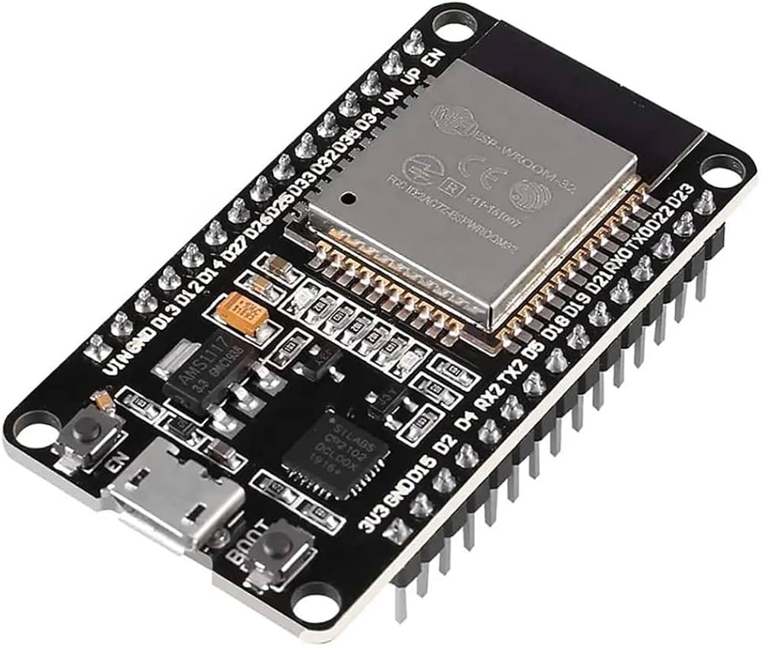
Water Level Sensor | Water level sensor, compatible with ESP32 | Detects the amount of water in the reservoir. | 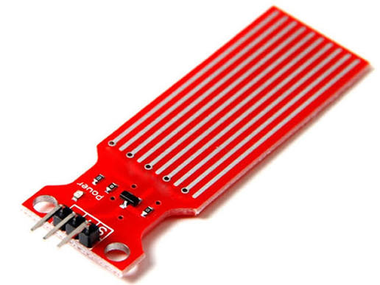
Motion Sensor | PIR motion sensor, 3.3V/5V compatible | Detects pet movement or activity. | 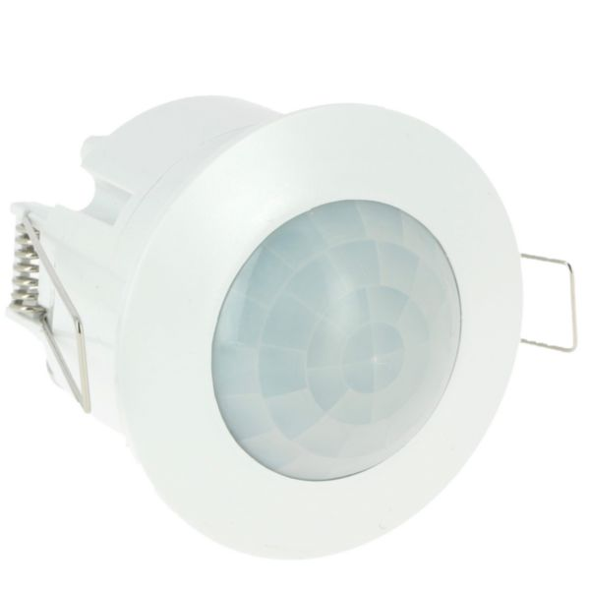
Rotating Camera | Wi-Fi camera module with pan/tilt capability | Allows remote monitoring of different areas around the pet. | 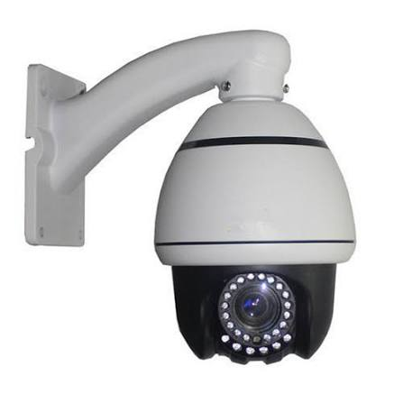
Automatic Feeder | Motorized automatic pet feeder mechanism | Dispenses pet food based on a schedule or user command. | 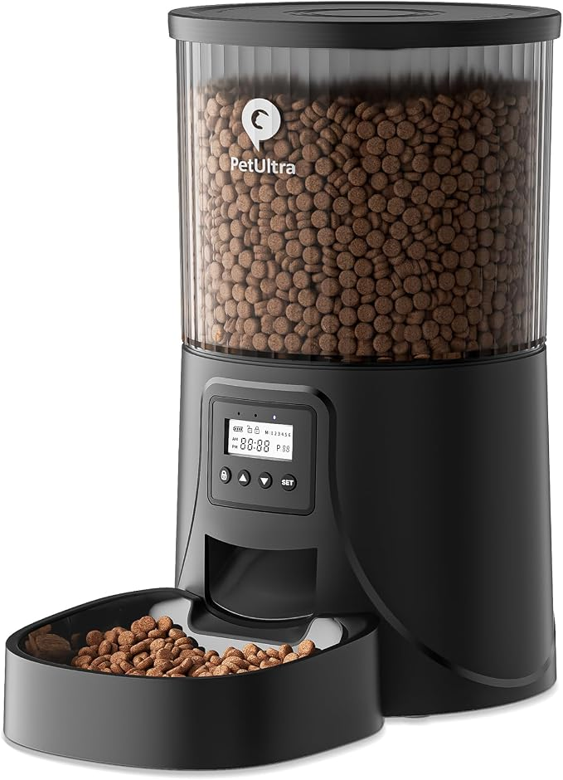
Servo Motor | Micro servo, ESP32-compatible | Controls the food dispensing mechanism. | 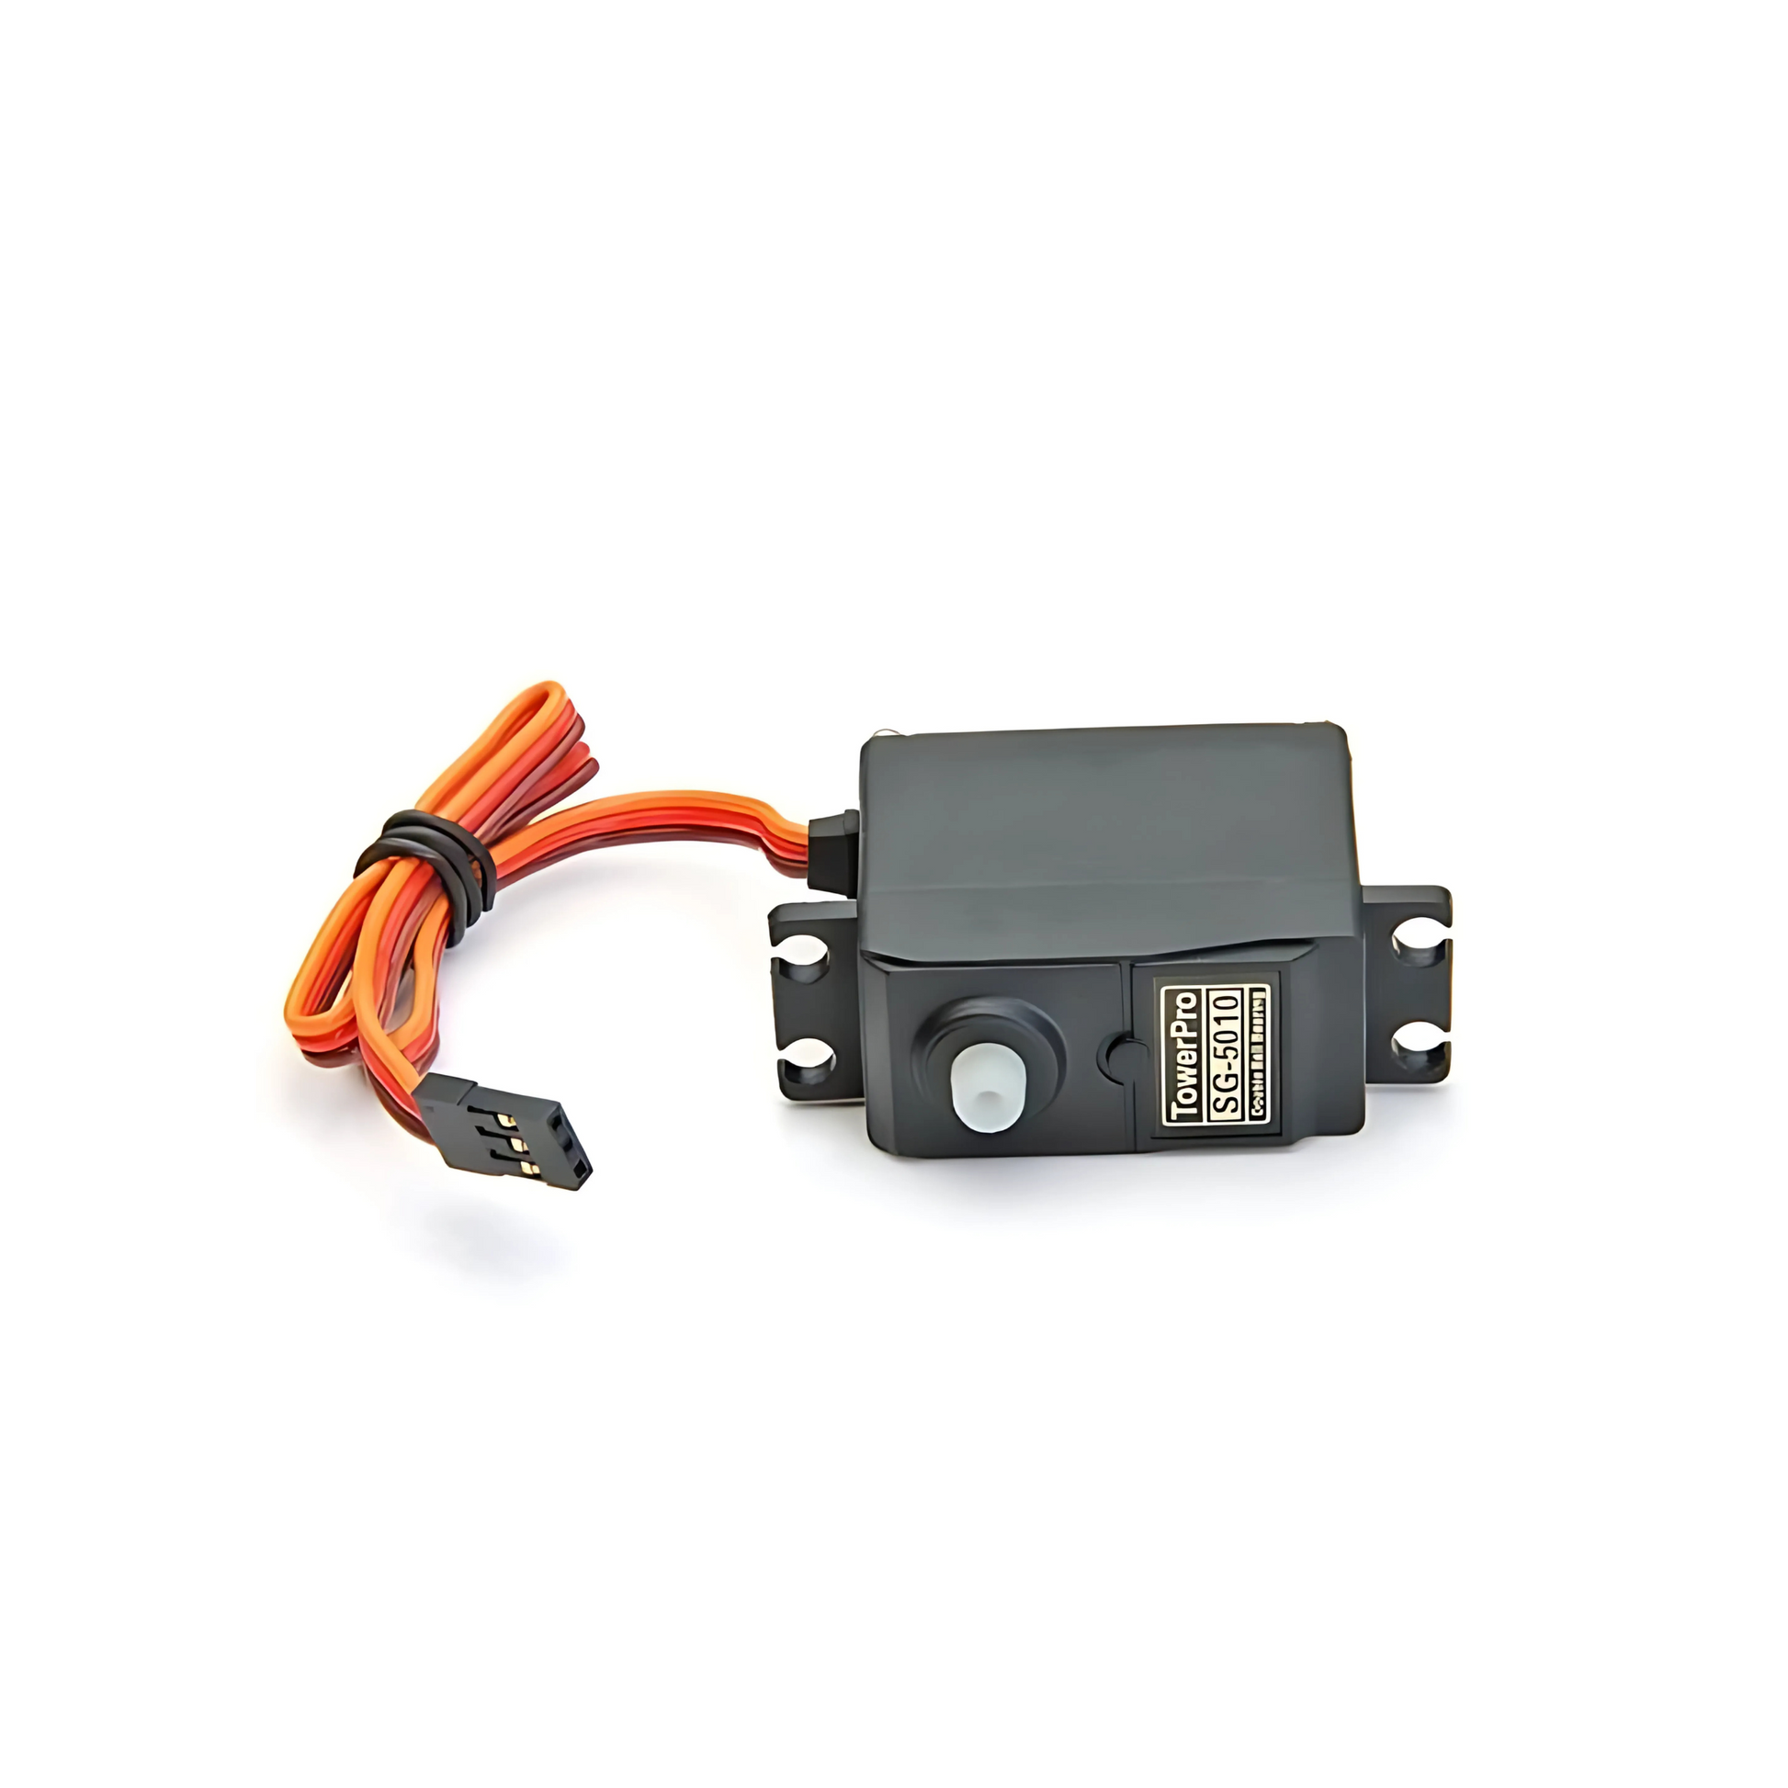
Water Pump | Small DC water pump | Moves water from the reservoir to the pet's bowl. | 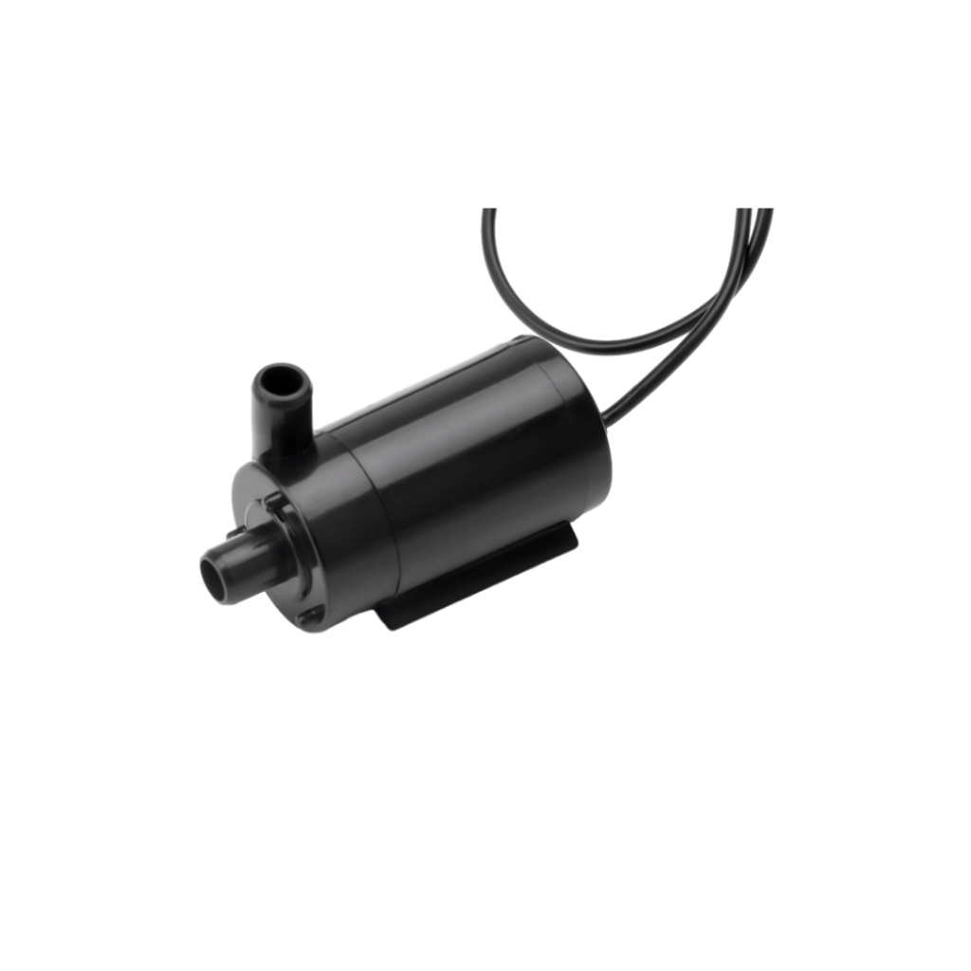
Relay Module | 1-channel relay module, ESP32-compatible | Controls higher-current devices such as the water pump. | 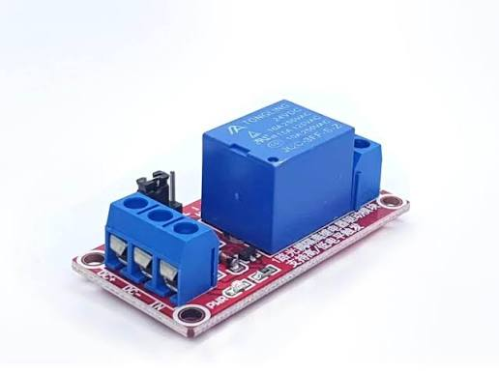
Food Reservoir | Food-grade container/reservoir | Stores pet food before dispensing. | 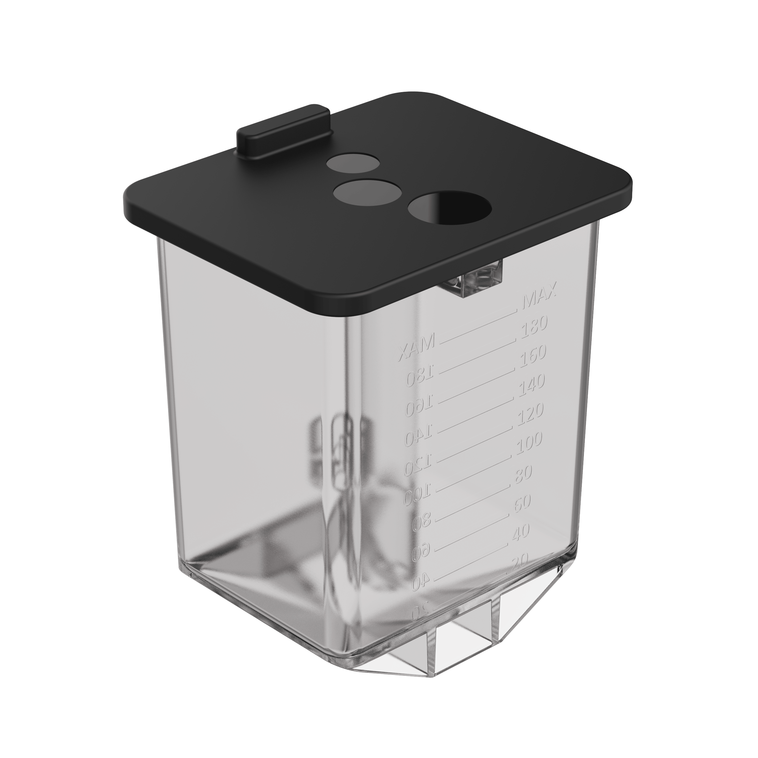
Water Reservoir | Food/water-safe container | Stores drinking water for automatic supply. | 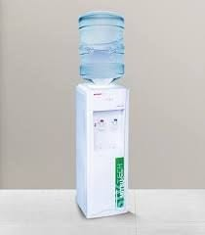
Feeding Bowl | Pet feeding bowl | Receives dispensed food for the pet. | 
Water Bowl | Pet water bowl | Provides drinking water to the pet. | 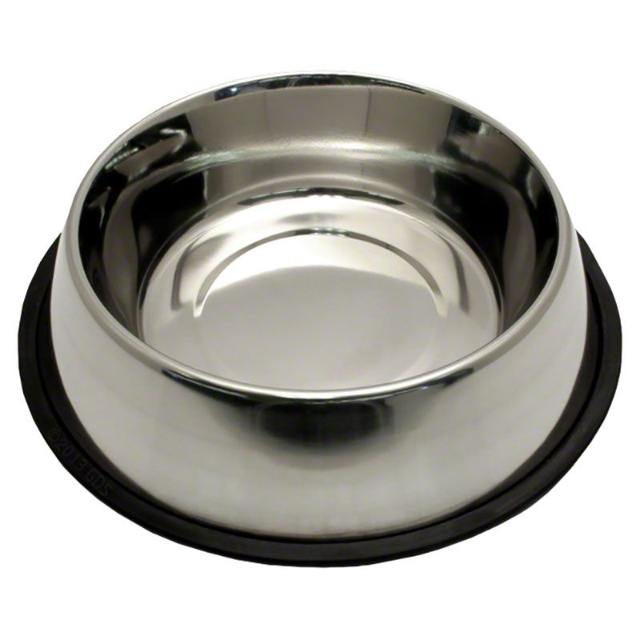
Power Supply | 5V/12V regulated DC power supply as required | Provides power to the controller and connected devices. | 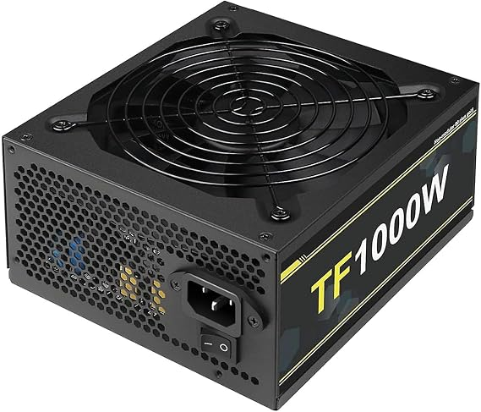
Breadboard / Prototype Board | Standard prototyping board | Used for initial circuit assembly and testing. | 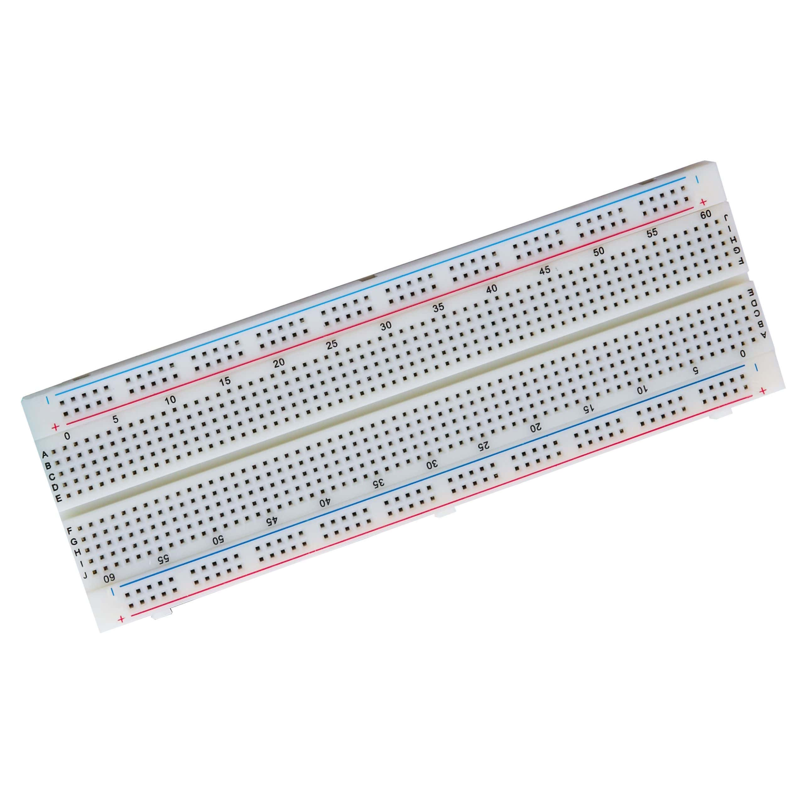
Jumper Wires | Male-to-male / male-to-female jumper wires | Connects sensors and modules during prototyping. | 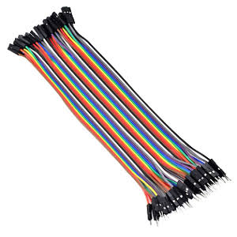
USB Cable | Data/power USB cable for ESP32 | Used for programming and powering the ESP32 during testing. | 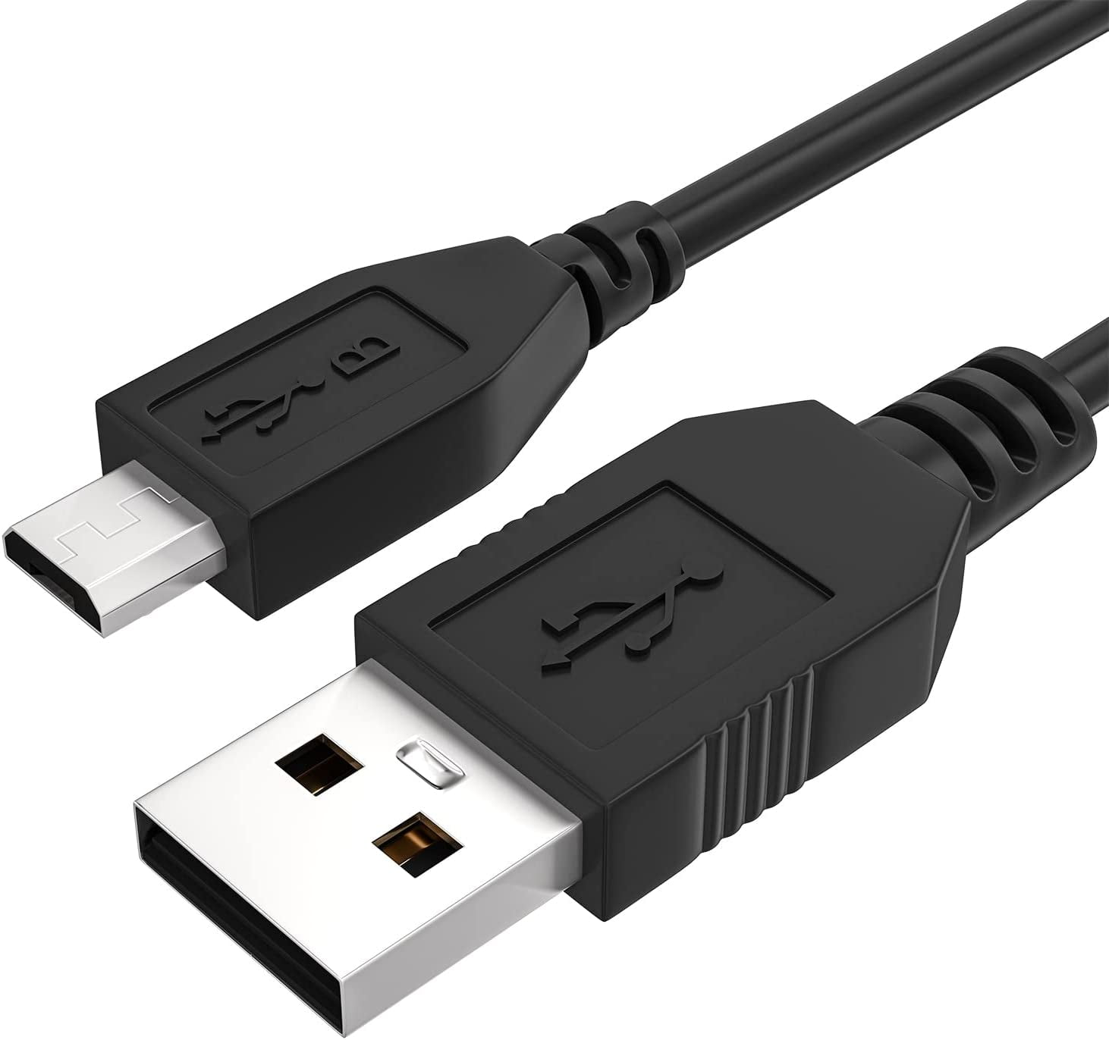
Voltage Regulator | DC-DC buck converter, adjustable | Provides suitable voltage to individual components. | 
Enclosure Hardware | Screws, brackets, spacers, mounting hardware | Secures the electronic components and mechanisms. | [Insert Picture]

2. Software
Materials / Product | Brand / Model / Specific Specification | Purpose | Picture
Petify Mobile Application | Proposed mobile application | Provides monitoring, control, notifications, and history access. | 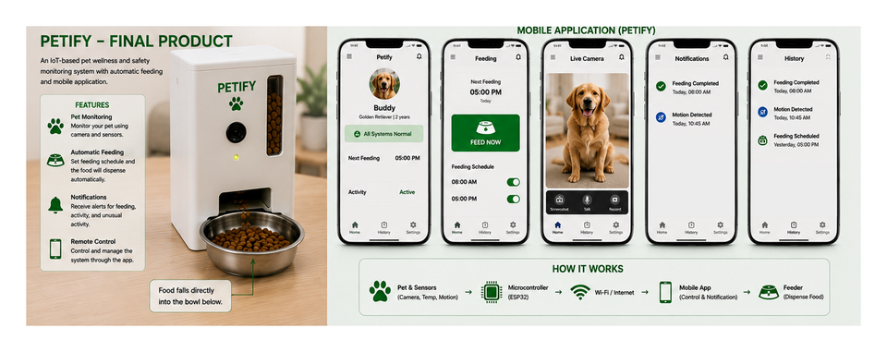
ESP32 Firmware | Arduino/C++ firmware for ESP32 | Processes schedules, sensor readings, and device commands. | 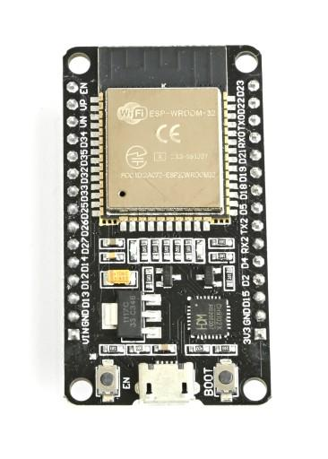
Feeding Control Module | Schedule and manual-control logic | Controls automatic and manual feeding. | 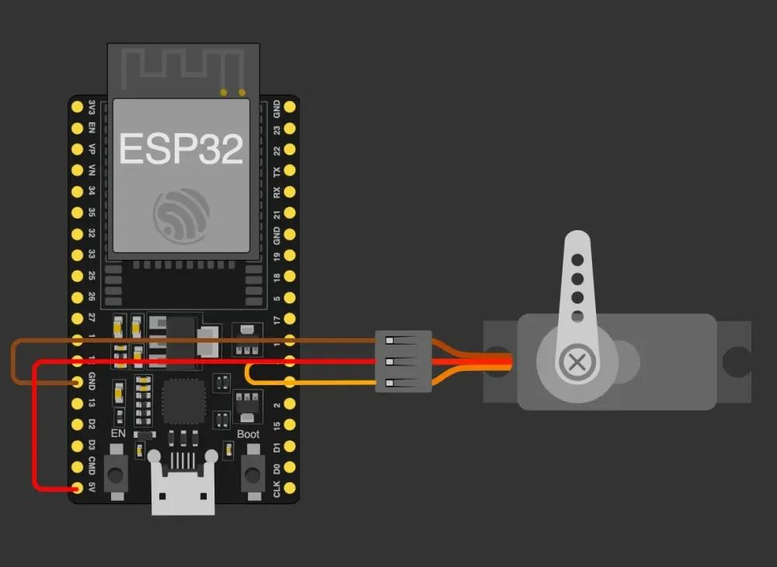
Water Monitoring Module | Water-level monitoring logic | Processes water-level readings and low-water conditions. | 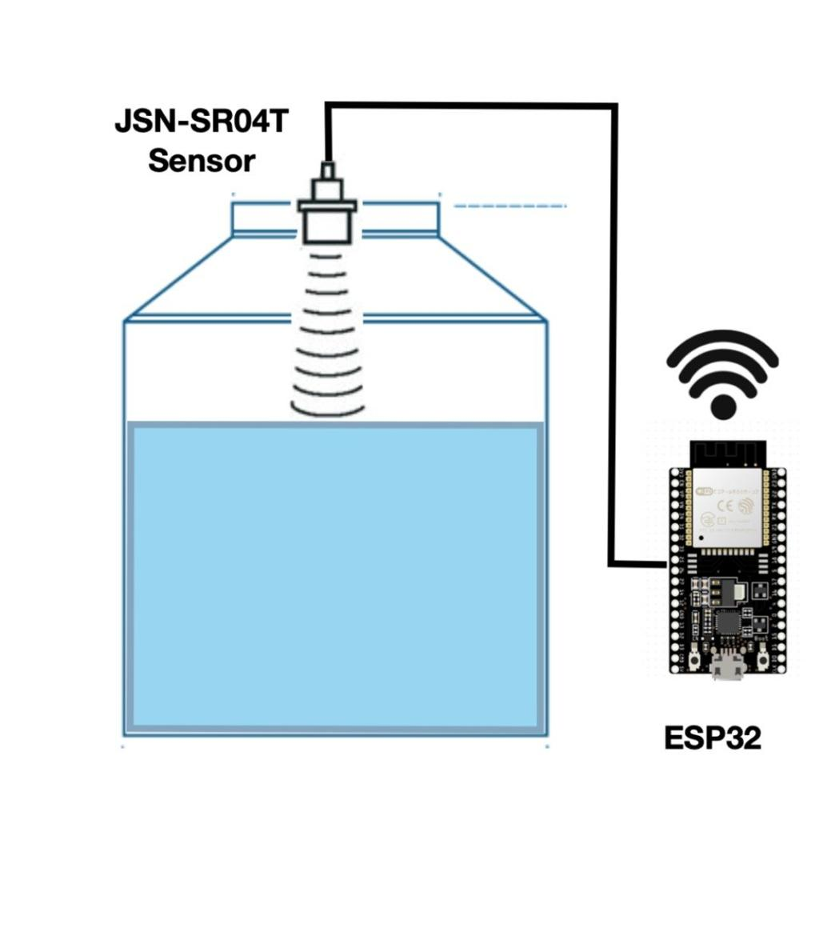
Camera Monitoring Module | Camera streaming/control interface | Allows the owner to view and control the rotating camera. | 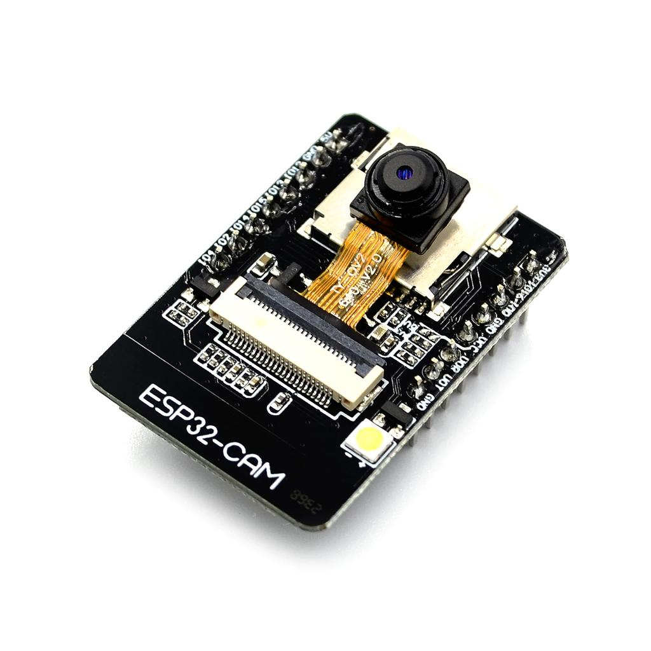
Notification Module | Push notification logic/service integration | Sends alerts such as low-water notifications. | 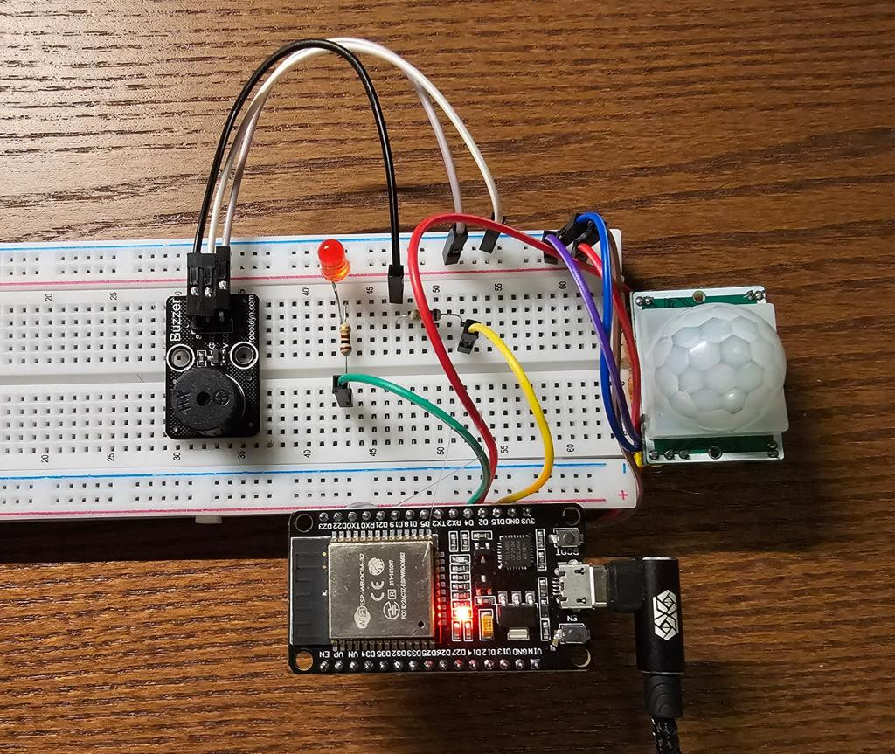
History Module | Feeding, water, and event logging | Records important Petify activities for later review. | 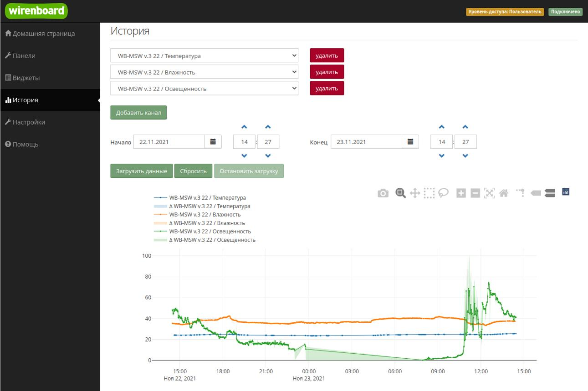
User Authentication | Email/password or equivalent login | Restricts application access to authorized users. | 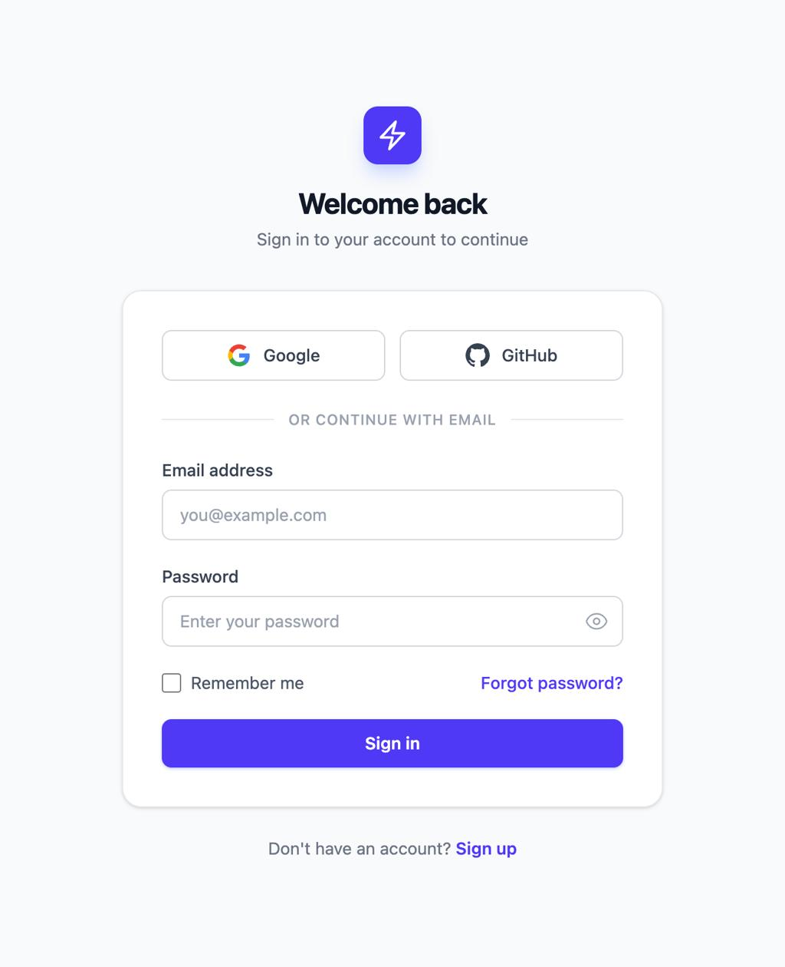
Database Integration | Proposed cloud database integration | Stores user, feeding, water, and event records for app access. | 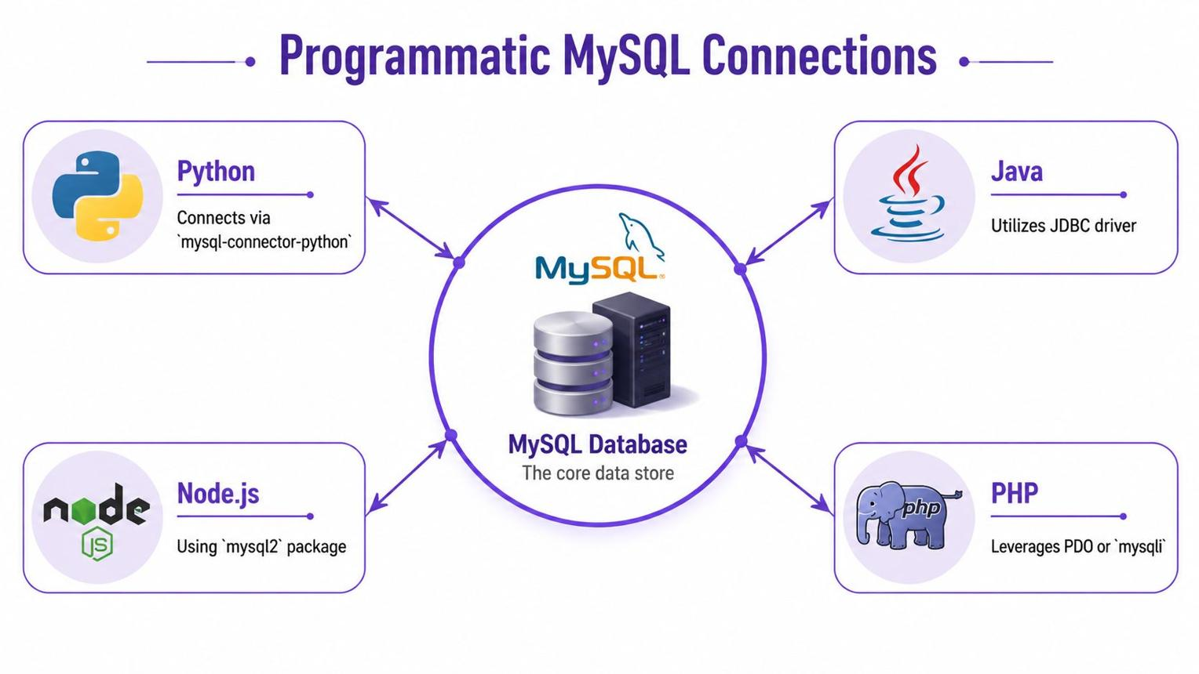
API / Device Communication | Proposed REST/IoT communication layer | Connects the mobile application with the IoT system. | 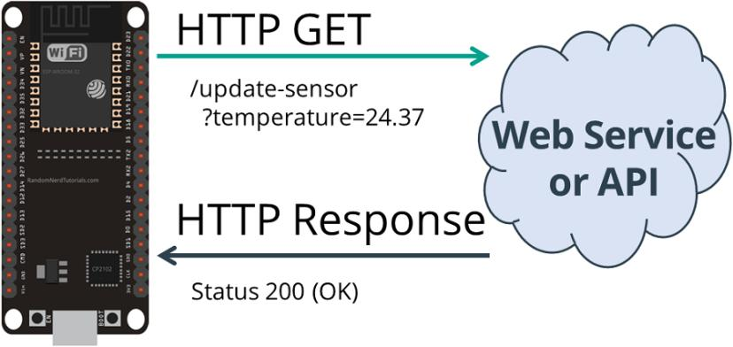
Development Environment | Arduino IDE / compatible ESP32 IDE | Used to develop and upload ESP32 firmware. | 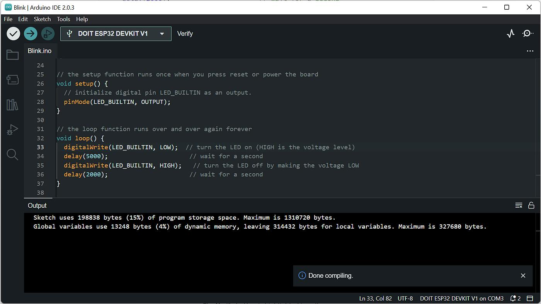
Testing Tools | Application and device testing tools | Used to check functionality, usability, and reliability. | 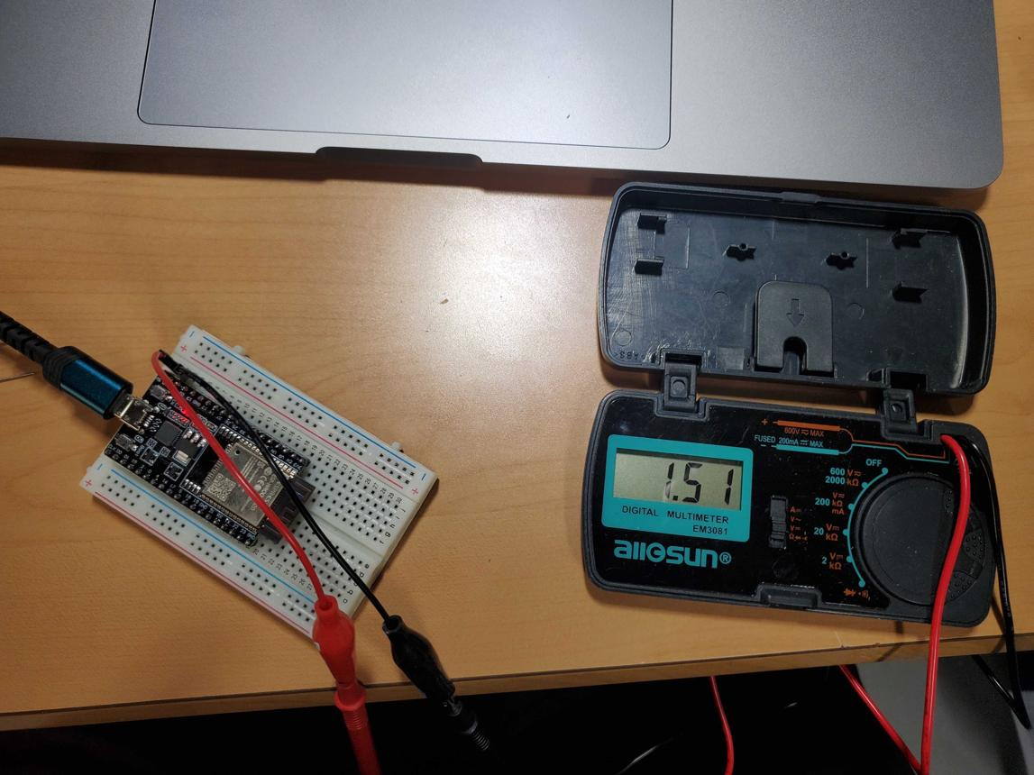

3. Network
Materials / Product | Brand / Model / Specific Specification | Purpose | Picture
Wi-Fi Router | 2.4 GHz Wi-Fi router, IoT-compatible | Provides local wireless connectivity for Petify devices. | 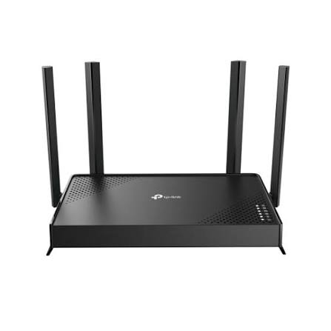
Wi-Fi Network | Secure WPA2/WPA3 wireless network | Connects ESP32 and network-enabled devices to the internet. | 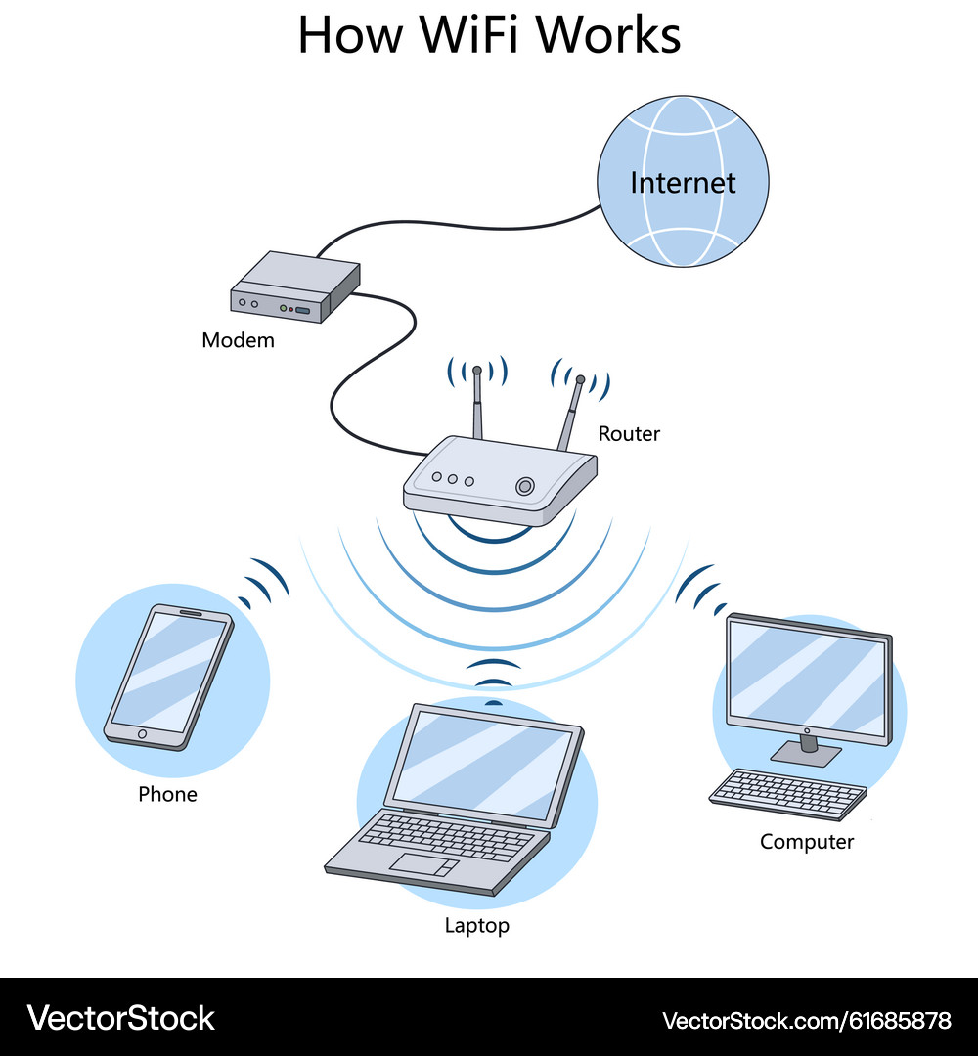
Internet Connection | Stable broadband/mobile internet connection | Enables remote monitoring, notifications, and app communication. | 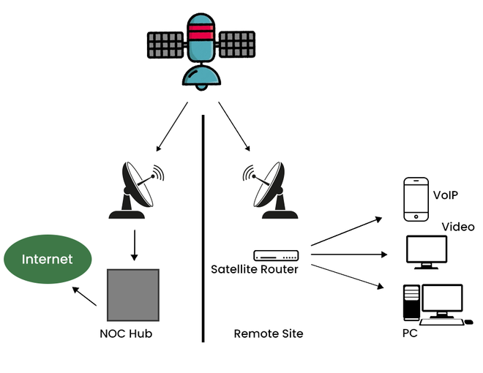
Network SSID | Dedicated Petify/IoT Wi-Fi SSID | Provides a dedicated network identity for system devices. | 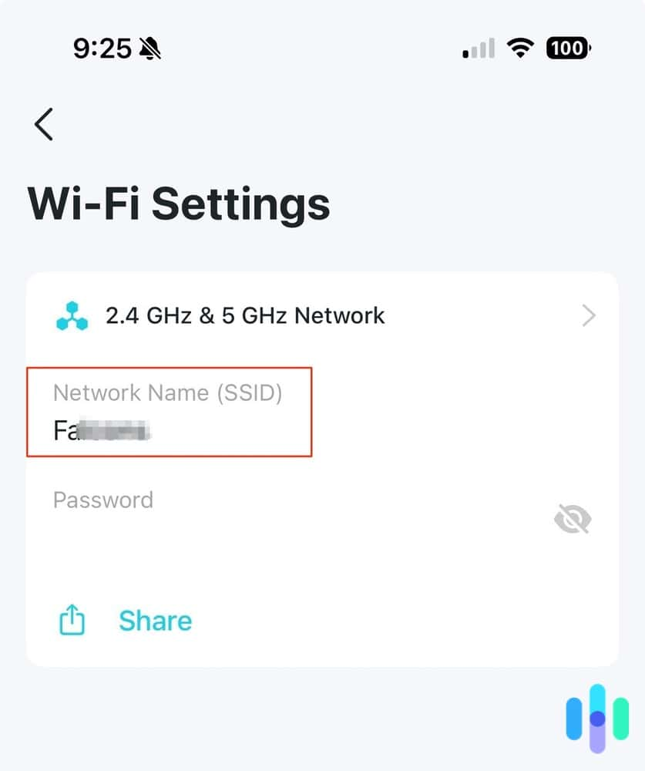
Network Password | Strong WPA2/WPA3 password | Protects the wireless network from unauthorized access. | 
Ethernet Cable | Cat5e/Cat6 cable | Provides wired connectivity when required for network equipment. | 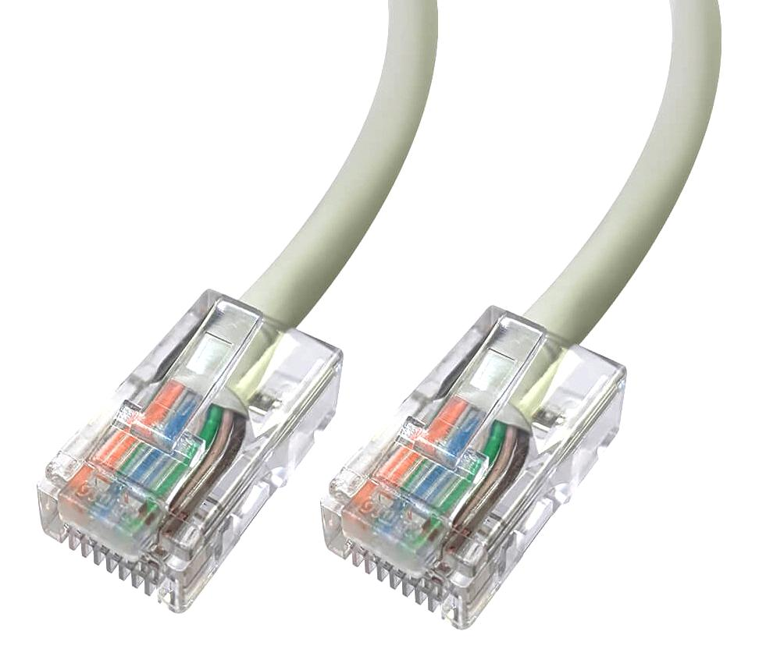
Network Adapter | Compatible Wi-Fi/Ethernet adapter | Provides network connectivity for supporting equipment. | 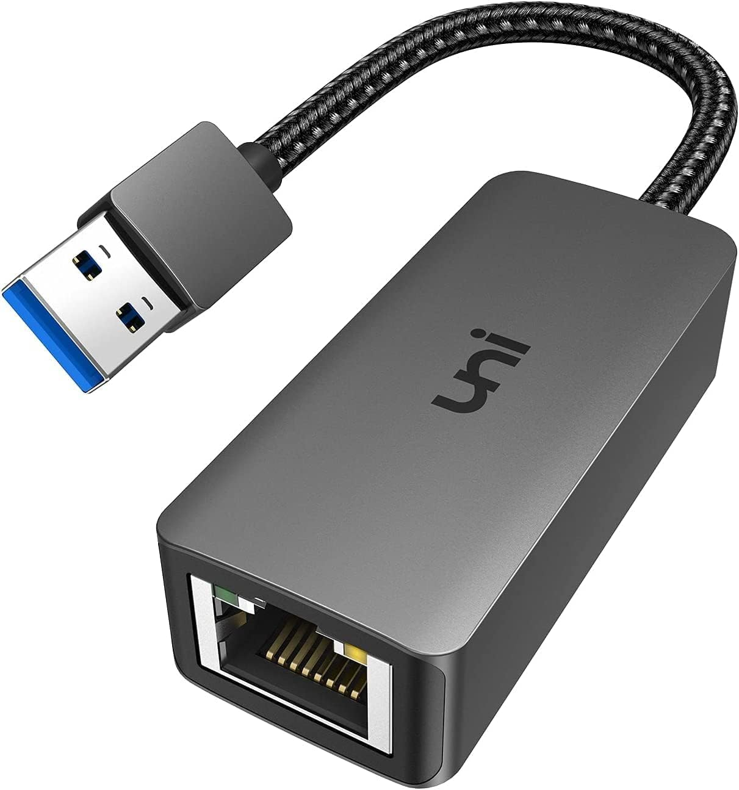
Firewall Function | Router firewall enabled | Filters unwanted network traffic reaching the system. | 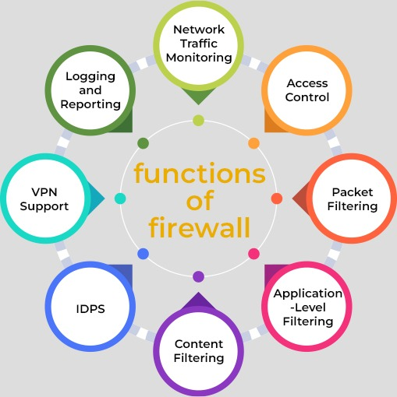
Network Monitoring | Router/device connection monitoring | Helps identify connectivity problems during operation. | 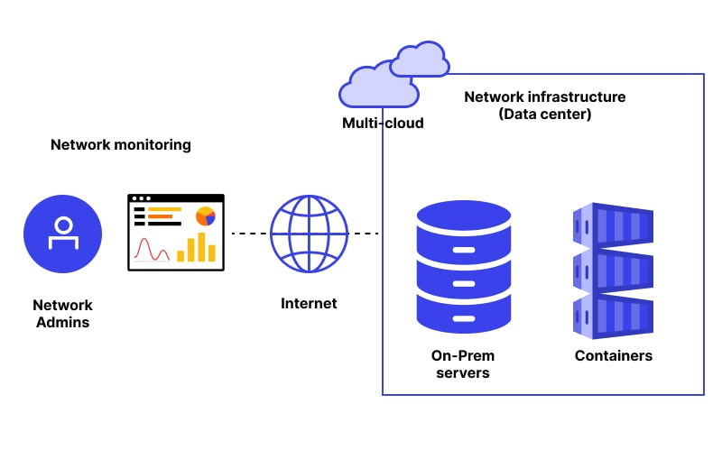
Remote Connectivity | Internet-based device-to-app communication | Allows the owner to monitor and control Petify while away. | 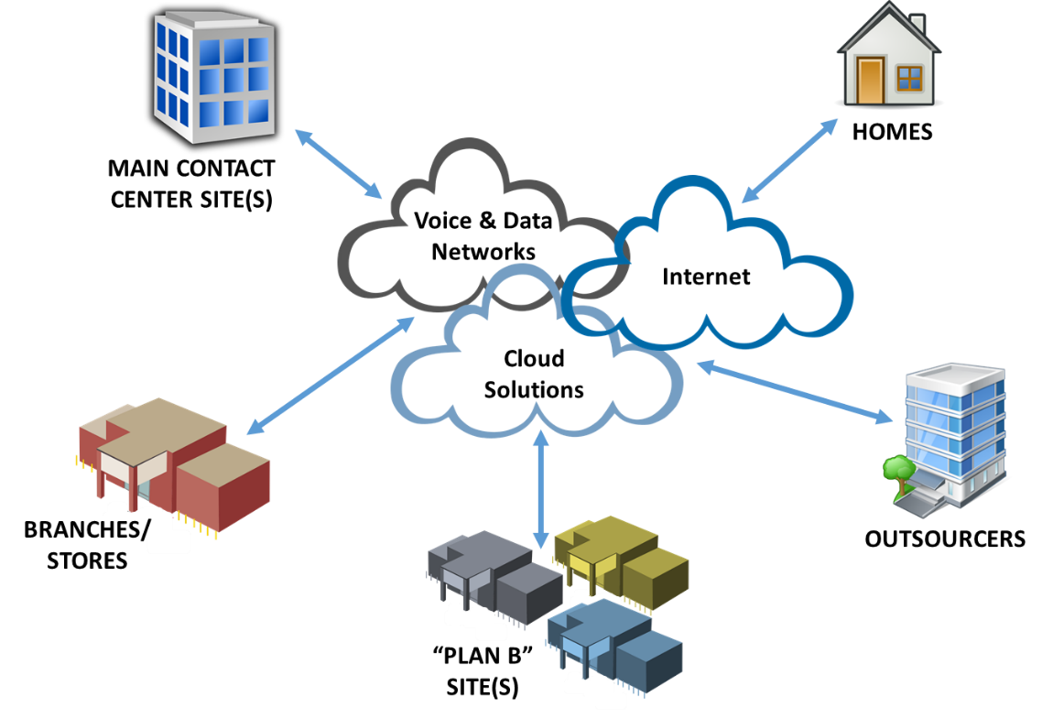

4. Storage
Materials / Product | Brand / Model / Specific Specification | Purpose | Picture
MicroSD Card | 32GB–128GB, Class 10 | Optional local storage for camera footage or event data. | 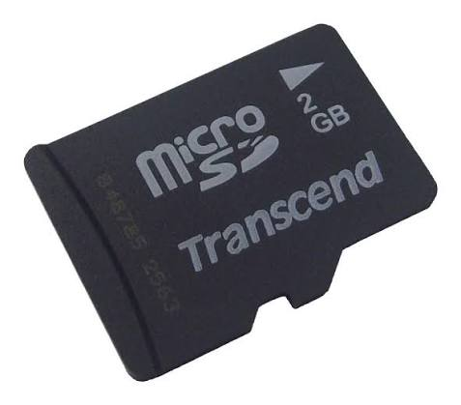
Cloud Database | Proposed Firebase/Firestore or equivalent | Stores user and system records for app access. | 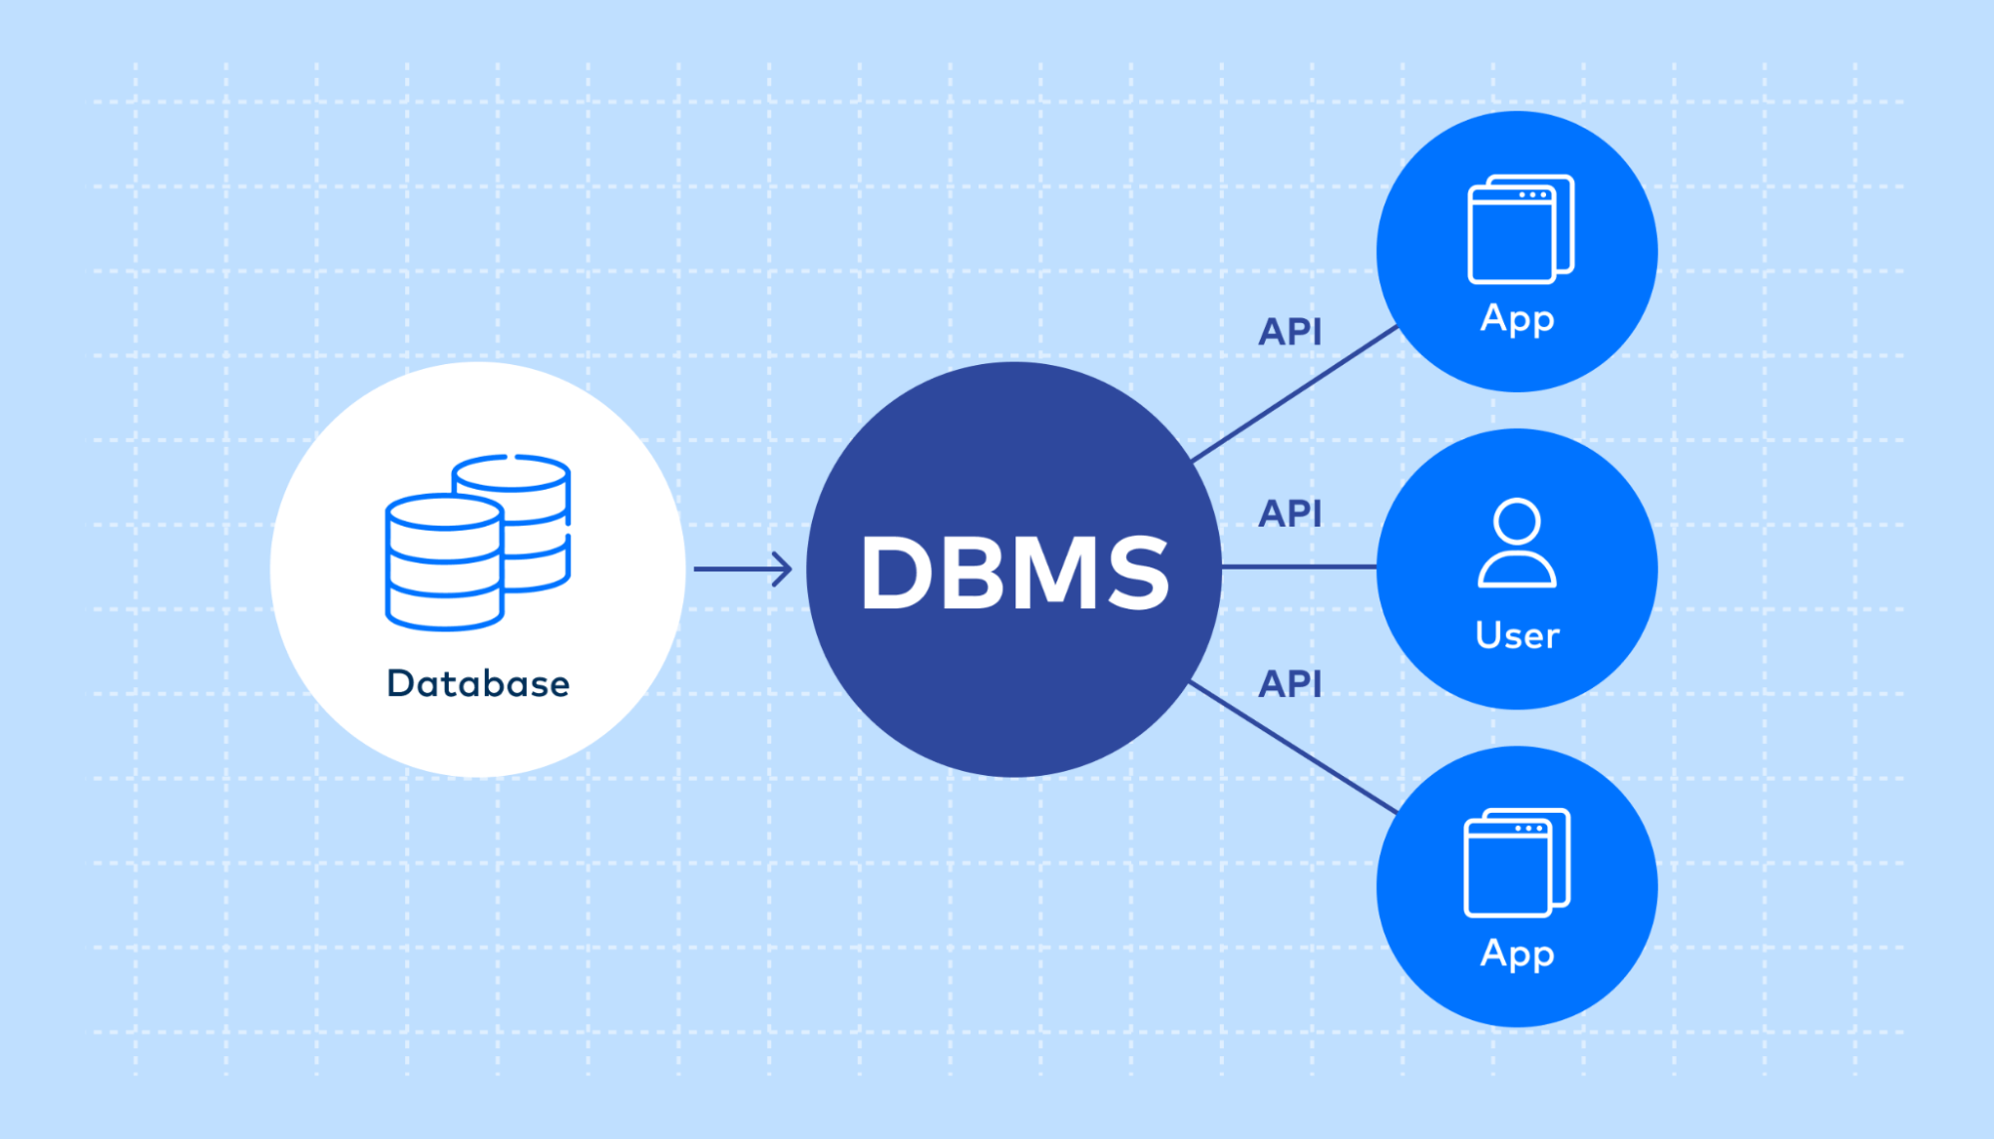
Cloud Storage | Proposed cloud object storage | Stores selected media or system files when needed. | 
Event History Storage | Feeding, water, motion, and system event records | Keeps a history that can be reviewed in the app. | 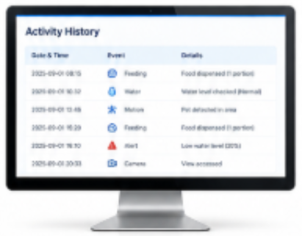
Feeding Records | Date, time, schedule, and feeding status | Documents feeding activities. | 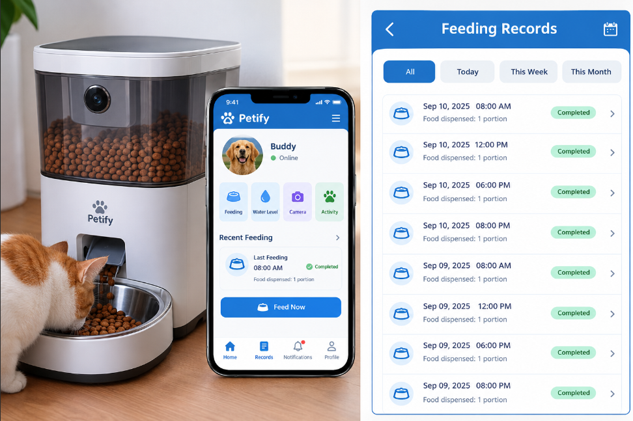
Water Records | Water-level readings and low-water events | Documents water monitoring information. | 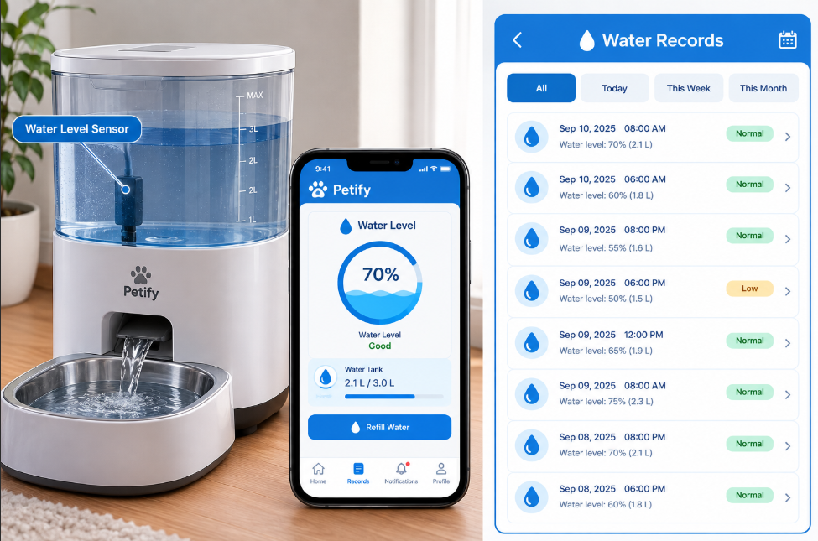
Backup Storage | Cloud or external backup location | Keeps backup copies of important system records. | 
Local Development Storage | Computer SSD/HDD | Stores source code, app assets, firmware, and project files. | 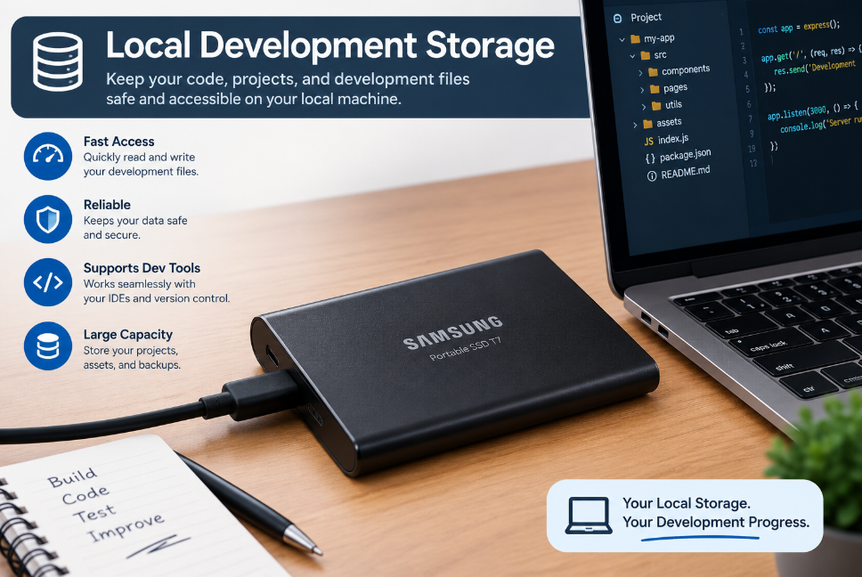

5. Security
Materials / Product | Brand / Model / Specific Specification | Purpose | Picture
User Authentication | Email/password authentication | Ensures only registered users can access Petify. | 
Access Control | Role/permission-based access where applicable | Limits actions to authorized users. | 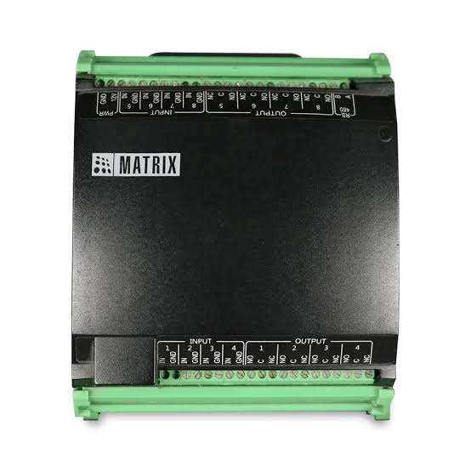
Password Protection | Strong password policy | Reduces the risk of unauthorized account access. | 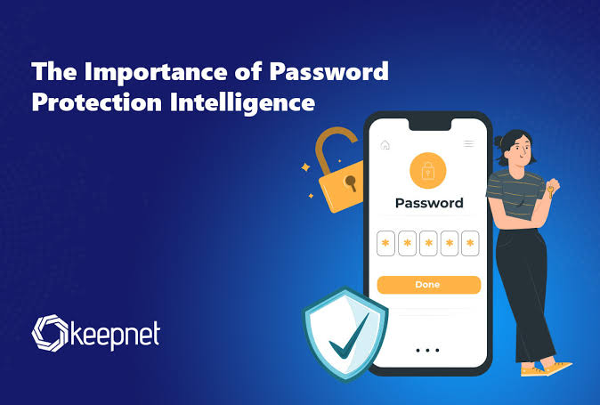
Wi-Fi Security | WPA2/WPA3 encryption | Protects wireless communication. | 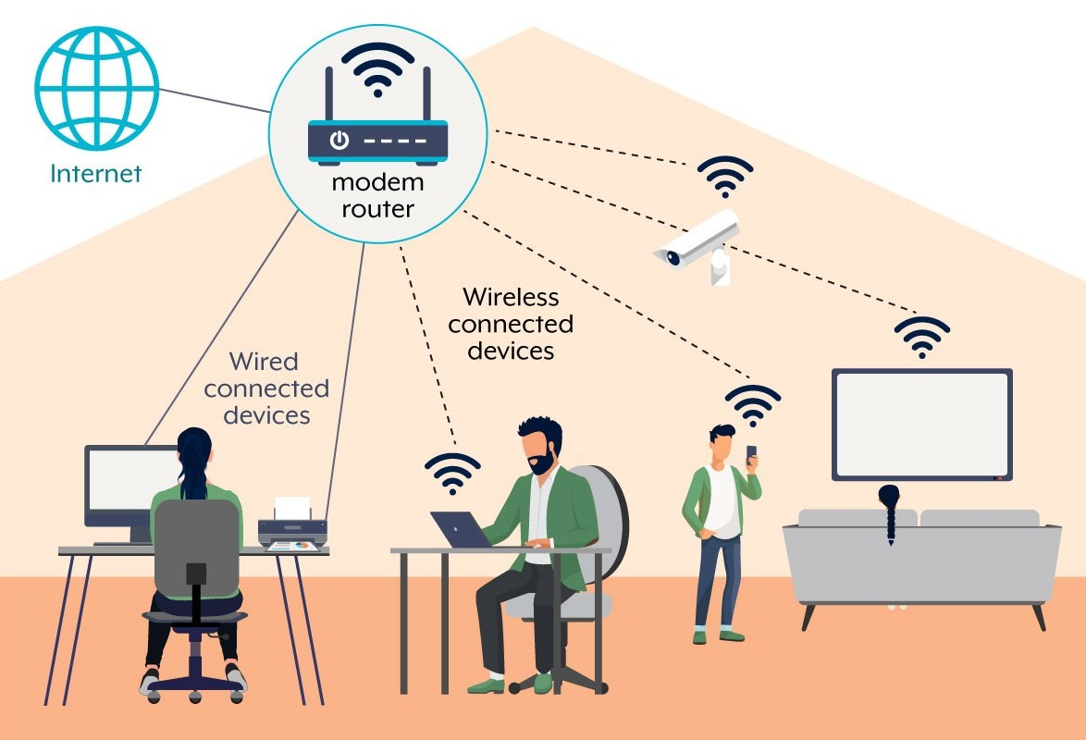
HTTPS/TLS | TLS-encrypted application communication | Protects data transmitted between the app and cloud services. | 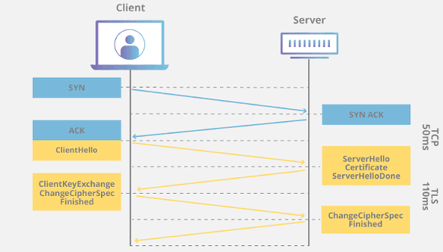
Secure API Access | Authenticated API requests | Prevents unauthorized device or data requests. | 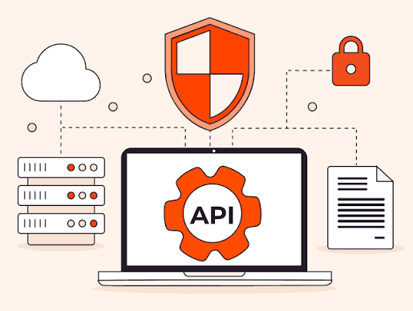
Firewall | Router firewall | Blocks unwanted incoming network traffic. | 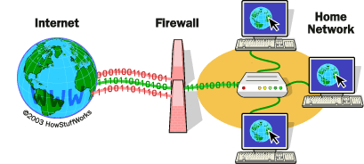
Device Access Protection | Restricted ESP32/device access | Prevents unauthorized physical or network control. | 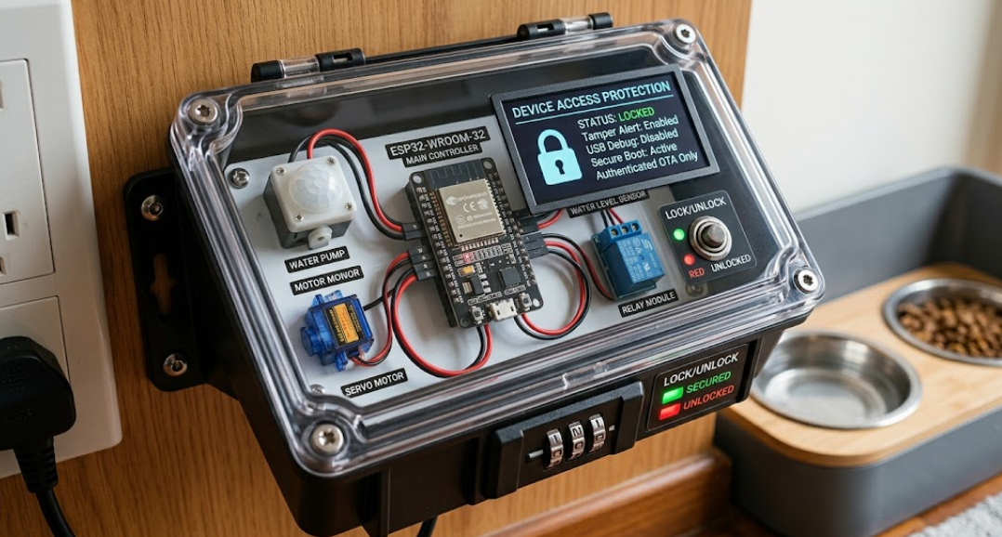
Secure Cloud Rules | Database/storage access rules | Restricts who can read or modify stored Petify data. | 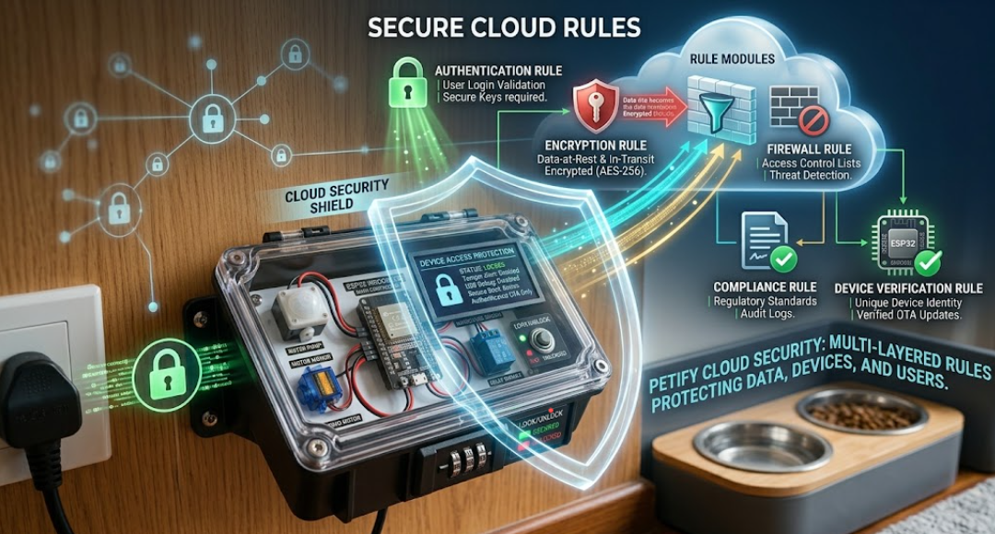
Backup Protection | Access-controlled backups | Protects copies of important records. | 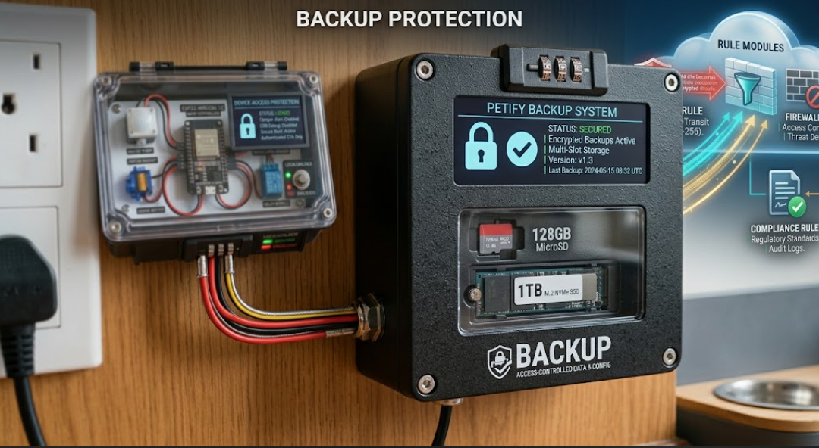
Session Security | Secure login/session handling | Reduces unauthorized access after login. | 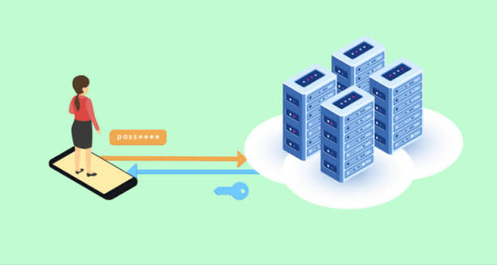
Security Testing | Authentication and communication testing | Checks whether the system is properly protected. | 

6. Facilities
Materials / Product | Brand / Model / Specific Specification | Purpose | Picture
Electronics Enclosure | Protective plastic/acrylic enclosure | Protects the ESP32 and electronic components. | 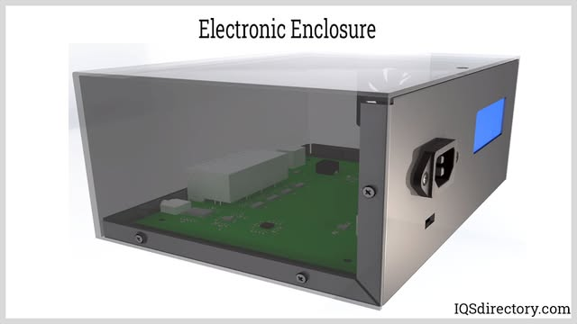
Camera Mount | Adjustable camera bracket | Holds the rotating camera in position. | 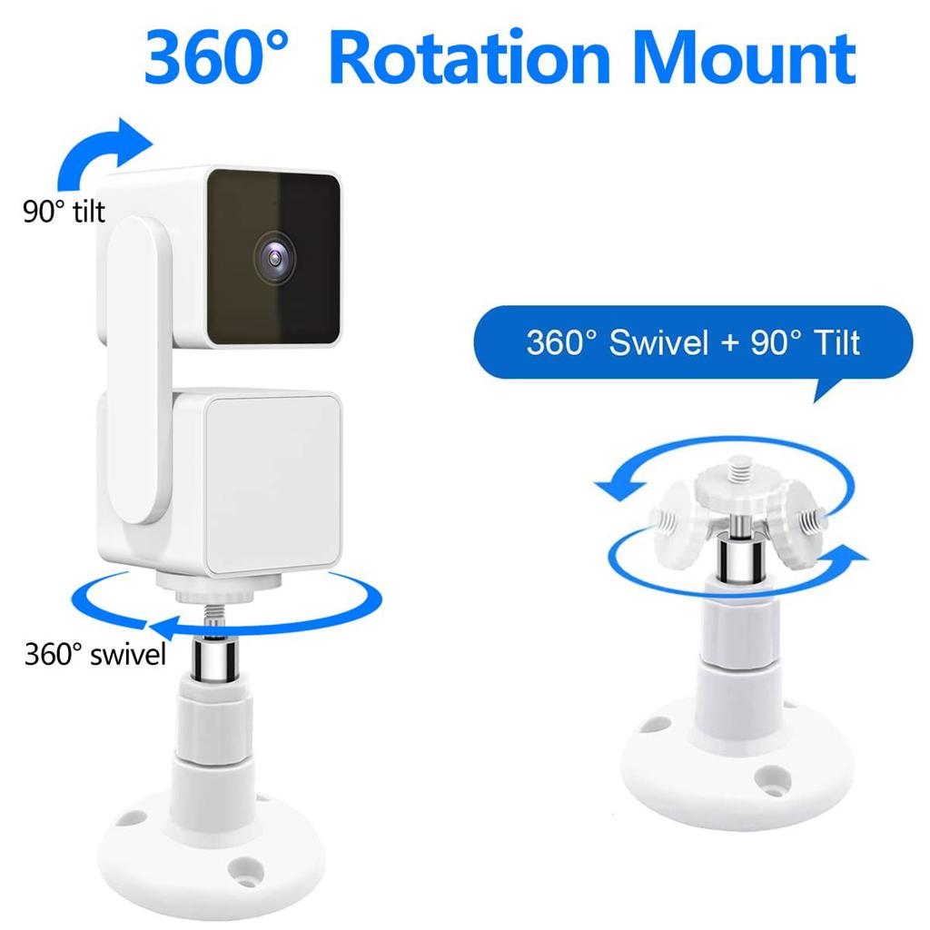
Device Base | Stable mounting platform | Keeps Petify components secure and organized. | 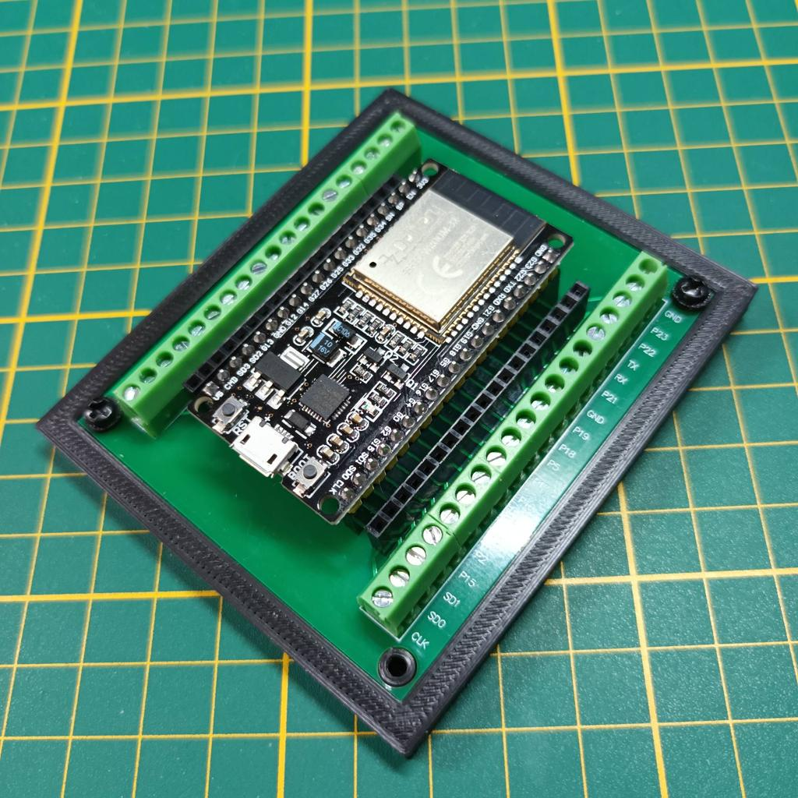
Cable Management | Cable sleeves, clips, and ties | Keeps wires organized and reduces accidental disconnection. | 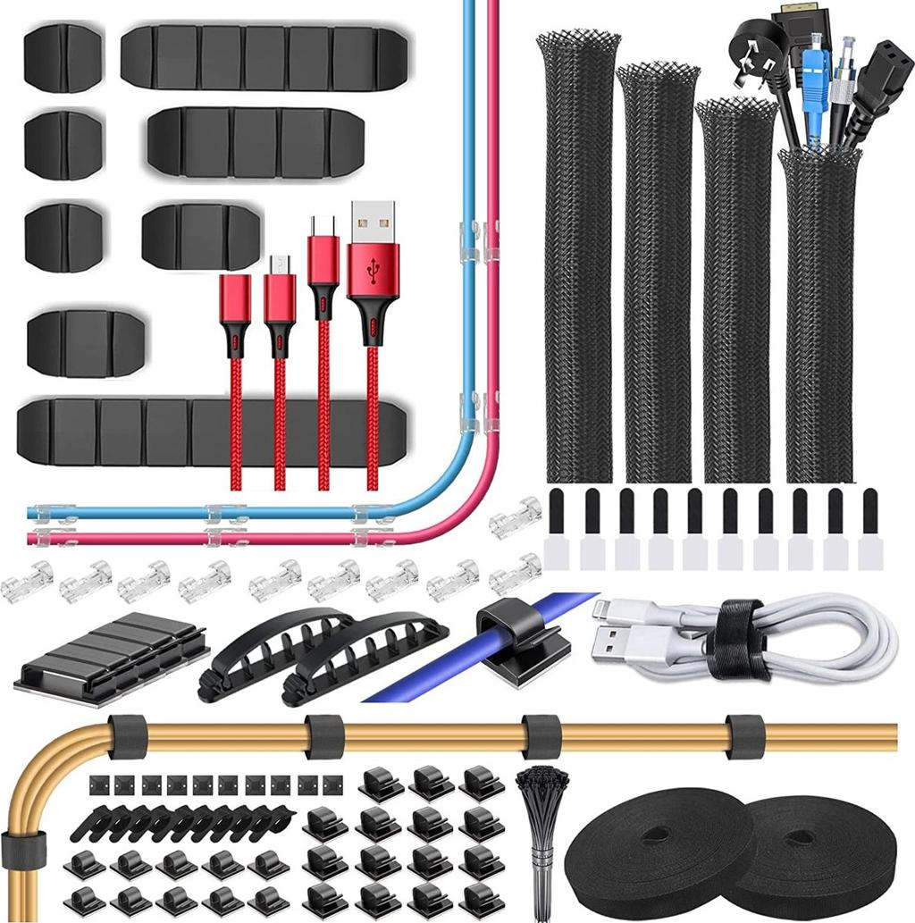
Cable Protection | Protective conduit/tubing | Helps protect cables from pets and environmental exposure. | 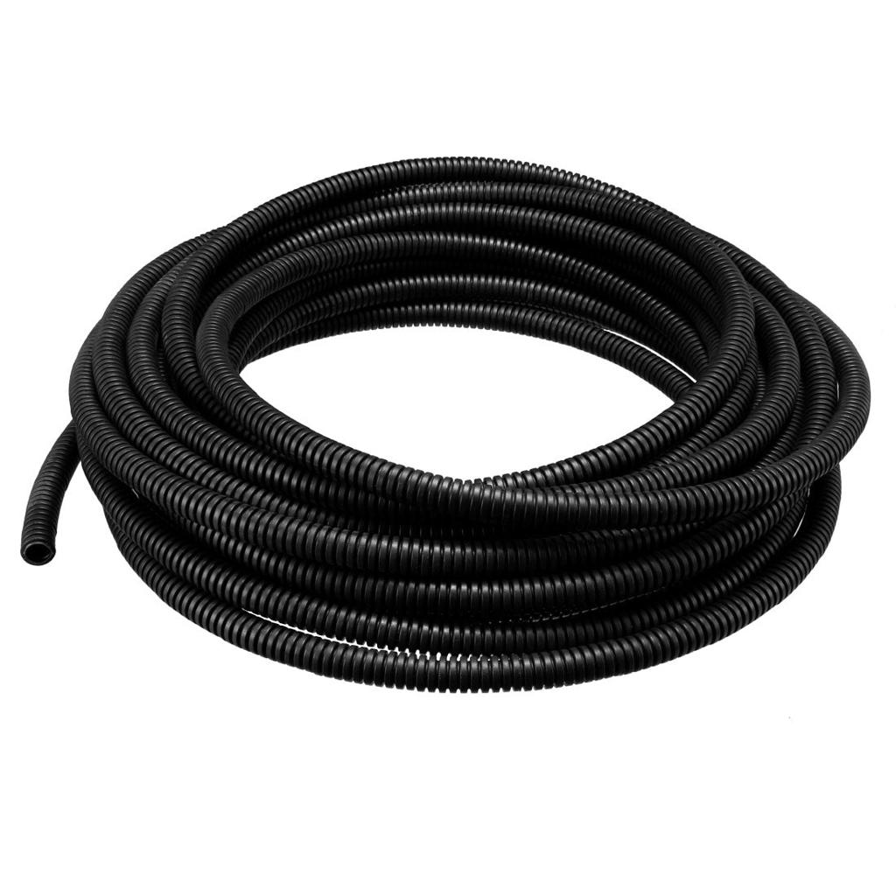
Food Storage Area | Clean, dry area for food reservoir | Keeps stored pet food protected and accessible to the feeder. | 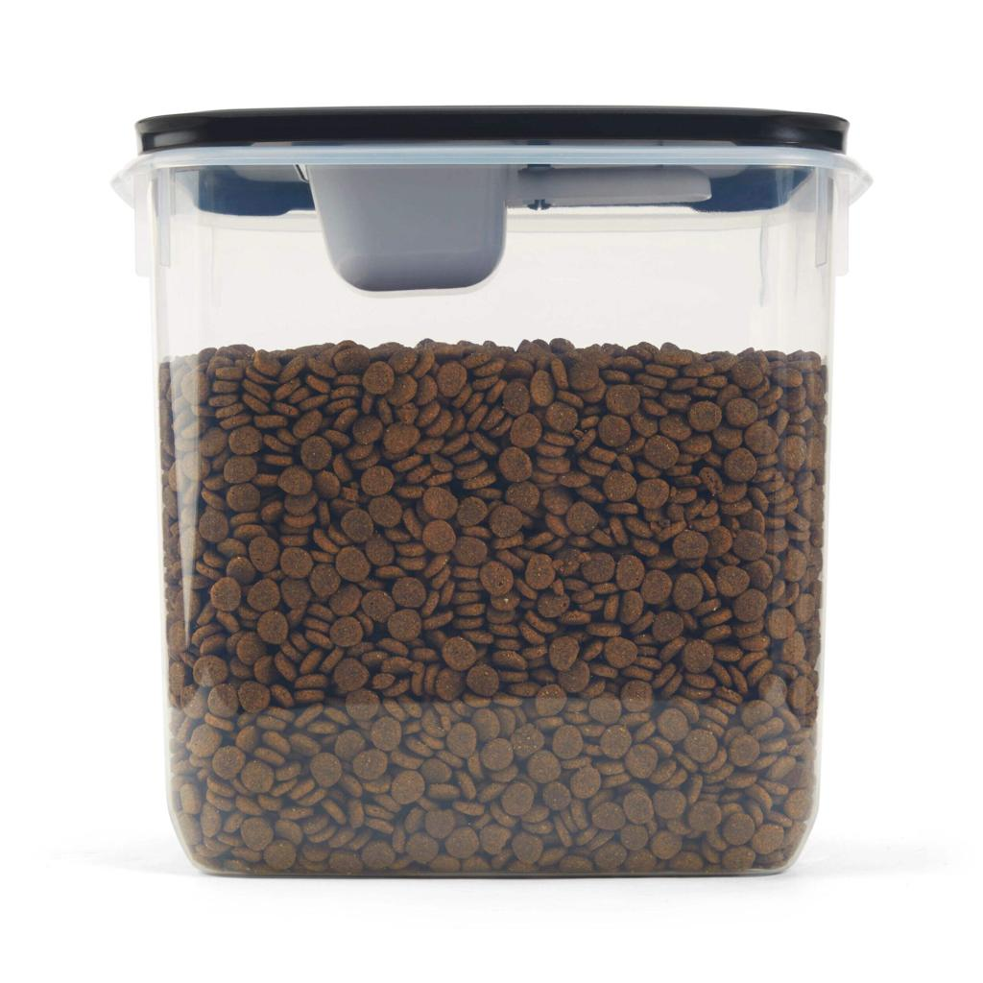
Water Storage Area | Stable area for water reservoir | Keeps the water container secure and positioned for dispensing. | 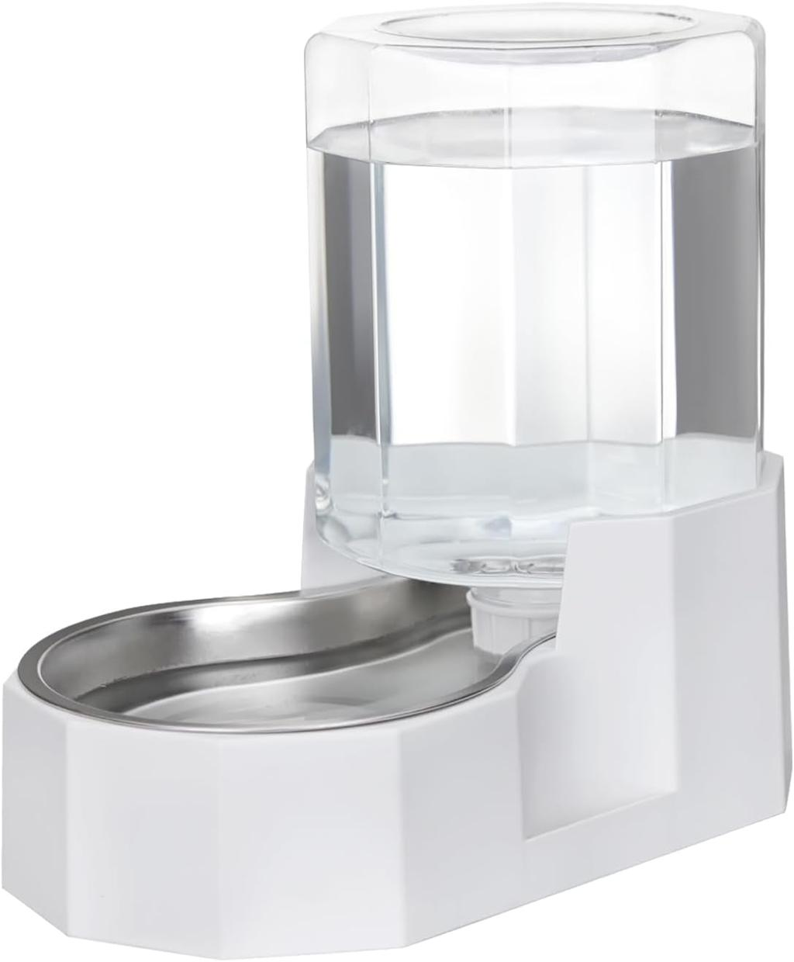
Feeding Area | Dedicated feeding-bowl space | Provides a stable location for food dispensing. | 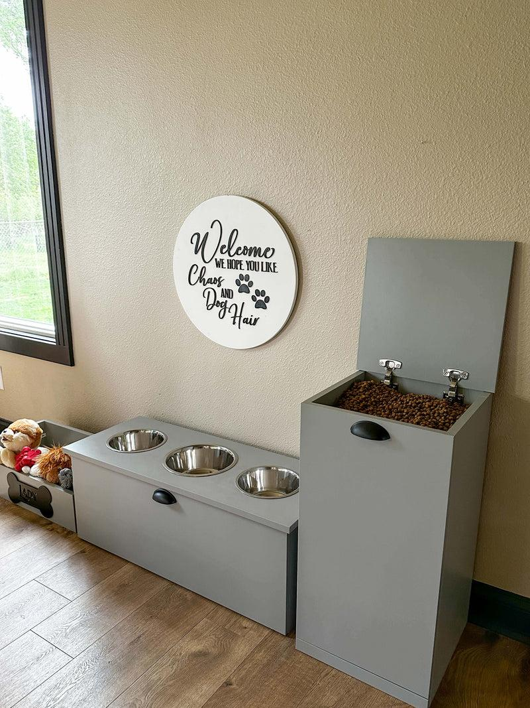
Water Area | Dedicated water-bowl space | Provides a stable location for drinking water. | 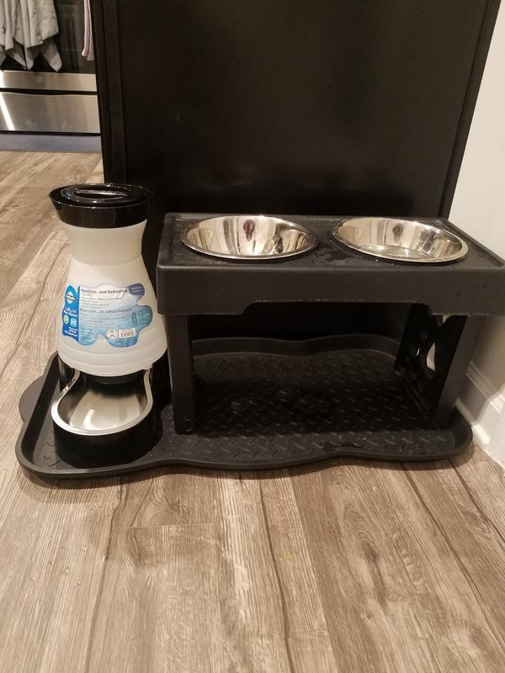
Power Area | Protected location for power supply | Keeps electrical power components organized and away from water. | 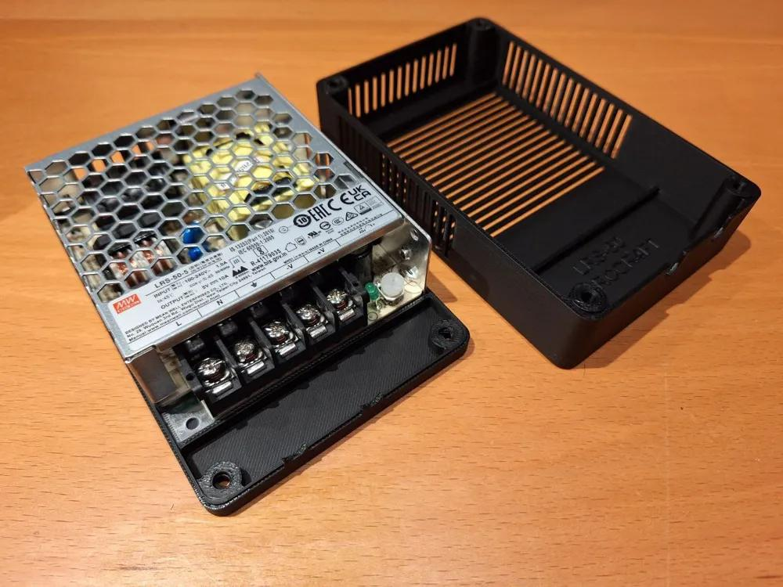
Ventilation | Ventilation openings for electronics enclosure | Helps prevent heat buildup around electronic components. | 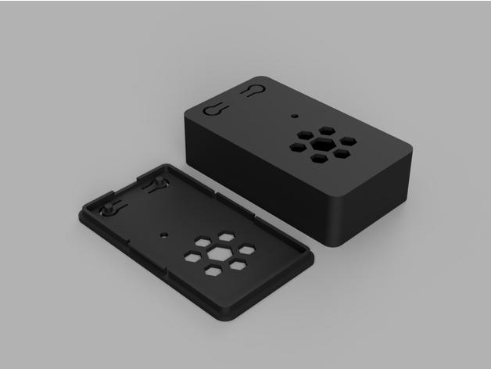
Work/Test Area | Clean electronics assembly and testing space | Supports safe development, wiring, and troubleshooting. | 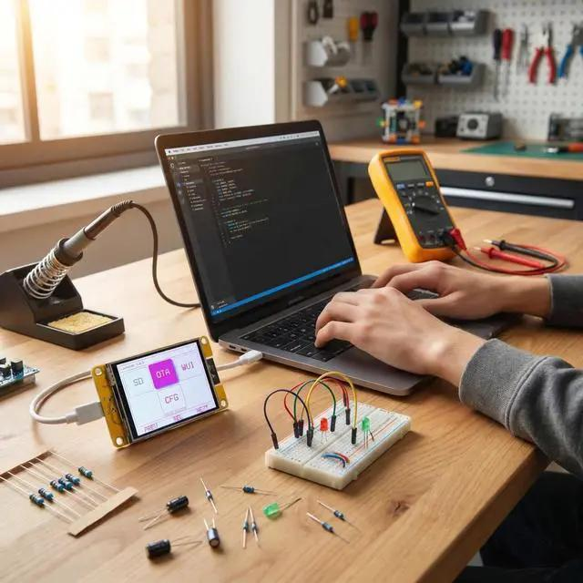

7. Cloud Services
Materials / Product | Brand / Model / Specific Specification | Purpose | Picture
Cloud Database | Proposed Firebase/Firestore or equivalent | Stores Petify user, feeding, water, and event data. | 
Cloud Storage | Proposed cloud file/object storage | Stores selected media or application files. | 
Push Notifications | Proposed Firebase Cloud Messaging or equivalent | Sends alerts such as low-water notifications to the mobile app. | 
Remote Access Service | Internet-based application access | Allows the owner to monitor and control Petify remotely. | 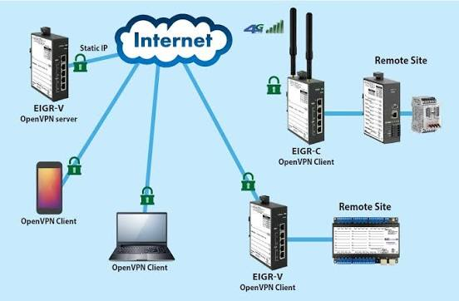
Authentication Service | Proposed cloud authentication service | Manages secure user sign-in and account access. | 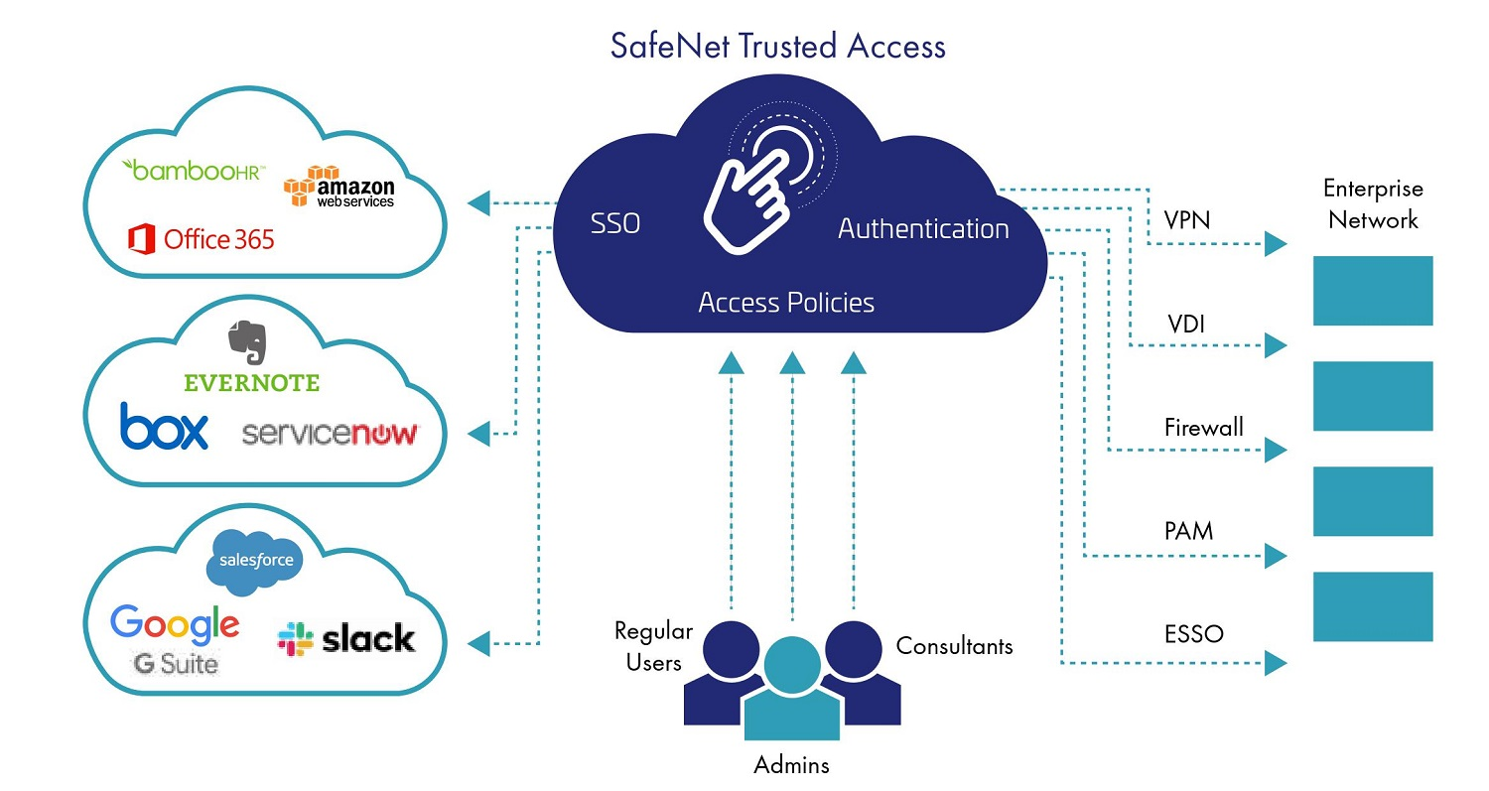
Cloud Backup | Scheduled cloud backup | Provides backup copies of important system data. | 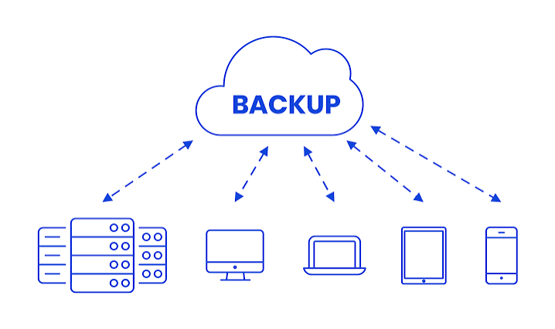
Monitoring / Logging | Cloud activity and error logs | Helps review system events and troubleshoot problems. | 
API Hosting / Gateway | Proposed secure cloud API endpoint | Handles communication between the mobile application and backend services. | 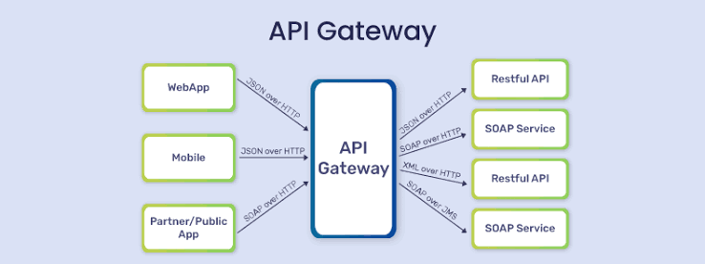
Database Security Rules | Authenticated read/write permissions | Protects stored Petify information from unauthorized access. | 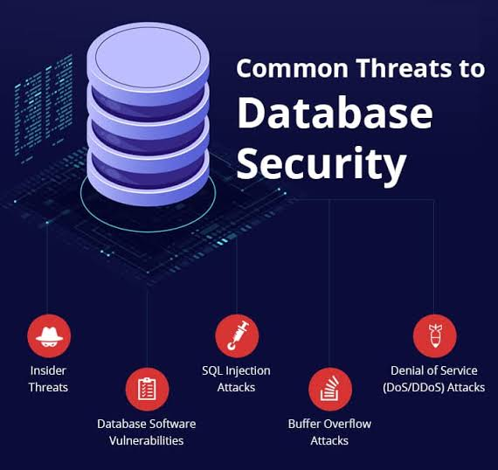
Service Availability | Cloud-hosted services with internet access | Supports continuous access to app data and notifications when connected. | 

